**IRIS CLASSIFICATION AND COMPARATIVE ANALYSIS OF DIFFERENT CLASSIFIERS IN SUPERVISED MACHINE LEARNING**

**Project report in partial fufillment of the requirement for the award of the degree of**

**Bachelor of Technology**

**In**

**COMPUTER SCIENCE**

**Submitted By**

RIJUSHREE GUHA University Roll No. 12019009002167

POULOMI BISWAS University Roll No. 12019009023042

ADITI MUKHERJEE University Roll No. 12019009001414

RAJDEEP MANDAL University Roll No. 12019009001236

SOUMYA DEY University Roll No. 12019009001403

SOMESWAR ROY University Roll No. 12019009001040

**Under the guidance of**

PROF. **SIBAPRASAD SEN**

Department of Computer Science



UNIVERSITY OF ENGINEERING & MANAGEMENT, KOLKATA

University Area, Plot No. III – B/5, New Town, Action Area – III, Kolkata – 700160.

**CERTIFICATE**

This is to certify that the project titled **IRIS FLOWER CLASSIFICATION USING MACHINE LEARNING** submitted by **RIJUSHREE GUHA (University Roll No. 12019009002167),** **POULOMI BISWAS (University Roll No. 12019009023042)**, **ADITI MUKHERJEE (University Roll No. 12019009001414) , RAJDEEP MANDAL(University Roll No. 12019009001236) , SOUMYA DEY(University Roll No. 12019009001403)** and **SOMESWAR ROY (University Roll No. 12019009001040)**, students of UNIVERSITY OF ENGINEERING & MANAGEMENT, KOLKATA, in partial fulfilment of requirement for the degree of Bachelor of Computer Science, is a bonafide work carried out by them under the supervision and guidance of Prof. **Sibaprasad Sen**  during 3rd Semester of academic session of 2020 - 2021. The content of this report has not been submitted to any other university or institute. I am glad to inform that the work is entirely original and its performance is found to be quite satisfactory.

_______________________________ _________________________________

Prof. **Sibaprasad Sen**  Prof. **Sukalyan Goswami**

Assistant Professor Head of the Department

Department of Computer Science Department of Computer Science

UEM, Kolkata UEM, Kolkata

**ACKNOWLEDGEMENT**

We would like to take this opportunity to thank everyone whose cooperation and encouragement throughout the ongoing course of this project remains invaluable to us.

We are sincerely grateful to our guide Prof. **Sibaprasad Sen** of the Department of Computer Science, UEM, Kolkata, for his wisdom, guidance and inspiration that helped us to go through with this project and take it to where it stands now.

We would also like to express our sincere gratitude to Prof. Sukalyan Goswami, HOD, Computer Science, UEM, Kolkata and all other departmental faculties for their ever-present assistant and encouragement.

Last but not the least, we would like to extend our warm regards to our families and peers who have kept supporting us and always had faith in our work.

RIJUSHREE GUHA

POULOMI BISWAS

ADITI MUKHERJEE

RAJDEEP MANDAL

SOUMYA DEY

SOMESWAR ROY

**Iris Dataset Classification and Comparative Analysis of different Classifiers using Machine Learning**

**TABLE OF CONTENTS**

|  |  |  |
| --- | --- | --- |
|  | **ABSTRACT** | **PAGE NO.** |
| **1.** | **Introduction** | **5** |
| **2.** | **Literature Survey** | **7** |
| **3.** | **Problem Statement** | **12** |
| **4.** | **Proposed Solution** | **13** |
| **5.** | **Experimental Setup and Result Analysis** | **22** |
| **6.** | **Comparative Analysis of classifiers** | **39** |
| **7.** | **Conclusion and Future Scope** | **41** |
| **8.** | **Bibliography** | **43** |
|  |  |  |

**INTRODUCTION**

**Machine learning** is an application of artificial intelligence (AI) that provides systems the ability to automatically learn and improve from experience without being explicitly programmed.

The primary aim is to allow the computers learn automatically without human intervention or assistance and adjust actions accordingly.

Machine learning algorithms are often categorized as supervised or unsupervised.

* **Supervised machine learning** algorithms can apply what has been learned in the past to new data using labeled examples to predict future events
* In contrast, **unsupervised machine learning** algorithms are used when the system doesn’t figure out the right output, but it explores the data and can draw inferences from datasets to describe hidden structures from unlabeled data.
* **Reinforcement machine learning** algorithms is a learning method that interacts with its environment by producing actions and discovers errors or rewards. Simple reward feedback is required for the agent to learn which action is best; this is known as the reinforcement signal.

Machine learning is about extracting knowledge from data. It is a research field at the intersection of statistics, artificial intelligence, and computer science and is also known as predictive analytics or statistical learning. The application of machine learning methods has become present in everyday life. From recommendations of which movies to watch, to which products to buy and recognising your friends on social media, machine learning algorithms that learn from input/output pairs are called supervised learning algorithms because a “teacher” provides supervision to the algorithms in the form of the desired outputs for each example that they learn from. As creating a dataset of inputs and outputs is often a manual process, supervised learning algorithms are well understood and their performance is easy to measure. As stated before, we will be covering the **Iris Species classification** problem — a typical test case for many statistical classification techniques in machine learning. Here the model will predict the sepcies of flower by taking an unkown sample.

In machine learning, **classification** refers to a predictive modeling problem where a class label is predicted for a given example of input data. Examples of classification problems include: Given an example, classify if it is spam or not. Given a handwritten character, classify it as one of the known characters.

In this project we will do a comparative analysis of different classifiers on this dataset. So that we can also apply these classifers on other dataset having the basic idea of which one is better based on the analysis.

**CHAPTER – 2 : LITERATURE SURVEY**

**Basic Introduction to Machine Learning**

Learning is a very important feature of Artificial Intelligence. Many scientist stried to explain and give a proper definition for learning. However, learning is not that easy to cover with few simple sentences. Many computer scientists, sociologists, logicians and other scientists discussed about this for a long time.Some scientists think learning is an adaptive skill so that the system can perform the similar task better in the next time (**Simon** 1987). Others claim that learning is a process of collecting knowledge (**Feigenbaum** 1977). Even though there is no proper definition for learning skill, we still need to give a definition for machine learning. In general, machine learning aims to find out how the computer algorithms can be improved automatically through experience (**Mitchell1997**). Machine learning has an important position in the field of Artificial Intelligence. At the beginning of development of Artificial Intelligence (AI), the AI system does not have a thorough learning ability so the whole system is not perfect. For instance, a computer cannot do self-adjustment when it faces problems. Moreover, the computer cannot automatically collect and discover new knowledge. The inference of the program needs more induction than deduction. Therefore, computer only can figure out already existing truths. It does not have the ability to discover a new logical theory, rules and so on.

**Fundamental Structure of Machine Learning System**

The environment represents a combination of information from external information source. That would include any information from persons or references materials and so on. It is the learning source for the whole machine learning system. The environment is responsible for transferring data to thesystem. The quality of the data is very important. In the reality, the data can be complex so it will be difficult for computer to process. In addition, the data can be incomplete, therefore the illation from the learning system is unauthentic. Learning is the procedure of transferring the information from the environment to knowledge. The environment will give the computer external information, and then the computer will go through all the information by using analysis, comprehensive induction and analogy to process this information to knowledge. At last, all the knowledge would be imported to the knowledge base. The knowledge base can be treated as the brain of the whole machine learning system. Different kinds of form and content of knowledge can have different influence on the designing of a machine learning system. Knowledge representation modes are eigenvector,

First-order logic statements, production rule, and semantic system. Every mode has its own advantages and disadvantages. Therefore, when users want to design a machine leaning system, a good knowledge representation mode is very important for the whole system.

A proper knowledge representation mode should satisfy four basic requirements:

1. Strong expression

2. Easy theorization

3. Easy to modify the knowledge base

4. Easy to expand the knowledge representation

Moreover, a machine learning system cannot create new knowledge from nothing. It always needs original knowledge to understand the information from environment. The complexity of knowledge is different depending on the different learning tasks. Some tasks are quite easy, so the system does not need too much information. If the tasks are quite difficult, the system will need more information to learn.

**Feedback**

After the execution, the execution system can evaluate the leaning task, and then give feedback

information to the learning process. The learning process will try to decide whether to collect information from environ…

**origin of iris classification**

The ***Iris* flower data set** or **Fisher's *Iris* data set** is a [multivariate](https://en.wikipedia.org/wiki/Multivariate_statistics) [data set](https://en.wikipedia.org/wiki/Data_set) introduced by the British [statistician](https://en.wikipedia.org/wiki/Statistician), [eugenicist](https://en.wikipedia.org/wiki/Eugenicist), and [biologist](https://en.wikipedia.org/wiki/Biologist) [Ronald Fisher](https://en.wikipedia.org/wiki/Ronald_Fisher) in his 1936 paper *The use of multiple measurements in taxonomic problems* as an example of [linear discriminant analysis](https://en.wikipedia.org/wiki/Linear_discriminant_analysis).[[1]](https://en.wikipedia.org/wiki/Iris_flower_data_set#cite_note-fisher36-1) It is sometimes called **Anderson's *Iris* data set** because [Edgar Anderson](https://en.wikipedia.org/wiki/Edgar_Anderson) collected the data to quantify the [morphologic](https://en.wikipedia.org/wiki/Morphology_(biology)) variation of [*Iris*](https://en.wikipedia.org/wiki/Iris_(plant)) flowers of three related species.[[2]](https://en.wikipedia.org/wiki/Iris_flower_data_set#cite_note-anderson36-2) Two of the three species were collected in the [Gaspé Peninsula](https://en.wikipedia.org/wiki/Gasp%C3%A9_Peninsula" \o "Gaspé Peninsula) "all from the same pasture, and picked on the same day and measured at the same time by the same person with the same apparatus".[[3]](https://en.wikipedia.org/wiki/Iris_flower_data_set#cite_note-anderson35-3) Fisher's paper was published in the journal, the [Annals of Eugenics](https://en.wikipedia.org/wiki/Annals_of_Eugenics), creating controversy about the continued use of the Iris dataset for teaching statistical techniques today.

**Fisher's linear discriminant model**

Based on Fisher's linear discriminant model, this data set became a typical test case for many [statistical classification](https://en.wikipedia.org/wiki/Statistical_classification) techniques in [machine learning](https://en.wikipedia.org/wiki/Machine_learning) such as [support vector machines](https://en.wikipedia.org/wiki/Support_vector_machines).[[5]](https://en.wikipedia.org/wiki/Iris_flower_data_set#cite_note-5)

The use of this data set in [cluster analysis](https://en.wikipedia.org/wiki/Cluster_analysis) however is not common, since the data set only contains two clusters with rather obvious separation. One of the clusters contains *Iris setosa*, while the other cluster contains both *Iris virginica* and *Iris versicolor* and is not separable without the species information Fisher used. This makes the data set a good example to explain the difference between supervised and unsupervised techniques in [data mining](https://en.wikipedia.org/wiki/Data_mining): Fisher's linear discriminant model can only be obtained when the object species are known: class labels and clusters are not necessarily the same.[[6]](https://en.wikipedia.org/wiki/Iris_flower_data_set#cite_note-6)

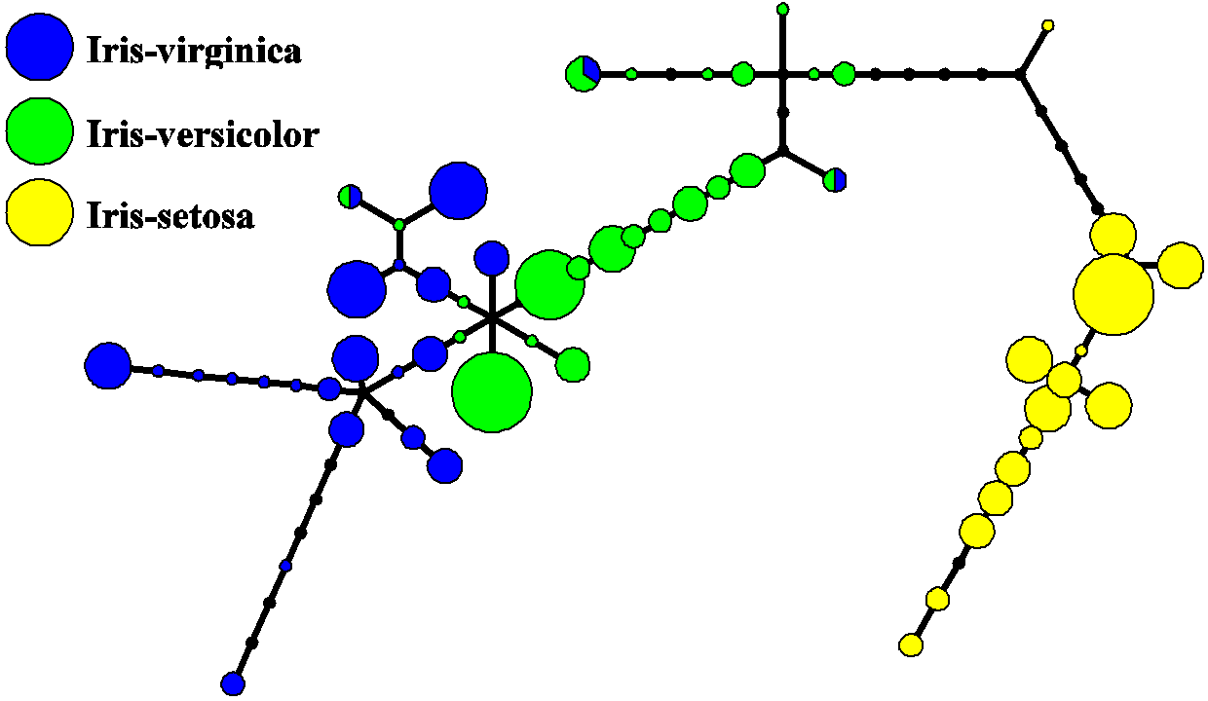

Nevertheless, all three species of *Iris* are separable. The data set is approximated by the closest tree with some penalty for the excessive number of nodes, bending and stretching. Then the so-called "metro map" is constructed.[[4]](https://en.wikipedia.org/wiki/Iris_flower_data_set#cite_note-GorbanZinovyev2010-4) The data points are projected into the closest node. For each node the [pie diagram](https://en.wikipedia.org/wiki/Pie_chart) of the projected points is prepared. The area of the pie is proportional to the number of the projected points. It is clear from the diagram (left) that the absolute majority of the samples of the different *Iris* species belong to the different nodes. Only a small fraction of *Iris-virginica* is mixed with *Iris-versicolor* (the mixed blue-green nodes in the diagram). Therefore, the three species of Iris (*Iris setosa*, *Iris virginica* and *Iris versicolor*) are separable by the unsupervising procedures of nonlinear [principal component analysis](https://en.wikipedia.org/wiki/Principal_component_analysis). To discriminate them, it is sufficient just to select the corresponding nodes on the principal tree.

The dataset contains a set of 150 records under five attributes - sepal length, sepal width, petal length, petal width and species.

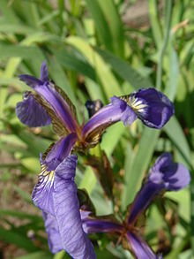

[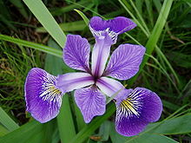](https://en.wikipedia.org/wiki/File:Iris_versicolor_3.jpg)

[*Iris versicolor*](https://en.wikipedia.org/wiki/Iris_versicolor)

[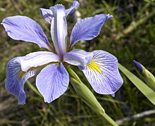](https://en.wikipedia.org/wiki/File:Iris_virginica.jpg)

[*Iris virginica*](https://en.wikipedia.org/wiki/Iris_virginica)

| **Fisher's *Iris* data**show |
| --- |
|  |

The iris data set is widely used as a beginner's dataset for machine learning purposes. The dataset is included in [R](https://en.wikipedia.org/wiki/R_(programming_language)) *base* and Python in the machine learning package [Scikit-learn](https://en.wikipedia.org/wiki/Scikit-learn" \o "Scikit-learn), so that users can access it without having to find a source for it.

A **supervised machine learning** algorithm (as opposed to an unsupervised machine learning algorithm) is one that relies on labeled input data to learn a

function that produces an appropriate output when given new unlabeled data.Imagine a computer is a child, we are its supervisor (e.g. parent, guardian, or teacher), and we want the child (computer) to learn what a pig looks like. We will show the child several different pictures, some of which are pigs and the rest could be pictures of anything (cats, dogs, etc).

When we see a pig, we shout “pig!” When it’s not a pig, we shout “no, not pig!” After doing this several times with the child, we show them a picture and ask “pig?” and they will correctly (most of the time) say “pig!” or “no, not pig!” depending on what the picture is. That is supervised machine learning

**PROBLEM STATEMENT**

Fisher’s Iris data base (Fisher, 1936) is perhaps the best known database to be found in the pattern recognition literature. The data set contains 3 classes of 50 instances each, where each class refers to a type of iris plant. One class is linearly separable from the other two; the latter are not linearly separable from each other.

The data base contains the following attributes:

1). sepal length in cm

2). sepal width in cm

3). petal length in cm

4). petal width in cm

5). class: - Iris Setosa

- Iris Versicolour

- Iris Virginica

Fisher’s Iris data base is available in Matlab (load fisheriris) and in Internet (for example, on <http://archive.ics.uci.edu/ml/datasets/Iris>). The goal of the project is to demonstrate the process of building a classifier that solves the classification problem.

Here we will be showing how to use several supervised learning classifier tools such as KNN classifier,random forest etc to build the classification model and predict the output labels given unkown data.

**AIM**:- To create the model that can classify the different species of the Iris flower when given an unkown parameters and comparative analysis of different classifiers

**PROPOSED SOLUTION**

[Supervised learning](https://scikit-learn.org/stable/supervised_learning.html#supervised-learning) consists in learning the link between two datasets: the observed data X and an external variable y that we are trying to predict, usually called “target” or “labels”. Most often, y is a 1D array of length n_samples.

All supervised [estimators](https://en.wikipedia.org/wiki/Estimator) in scikit-learn implement a fit(X, y) method to fit the model and a predict(X) method that, given unlabeled observations X, returns the predicted labels y.

Machine learning is about learning some properties of a data set and then testing those properties against another data set. A common practice in machine learning is to evaluate an algorithm by splitting a data set into two. We call one of those sets the **training set**, on which we learn some properties; we call the other set the **testing set**, on which we test the learned properties.

So to build a classification model on iris dataset we will be using seven kinds of classifiction algorithm one at a time :-

* At first we will use **K-Nearest Neighbor** classifier from scikit-learn to train the model and then test it on unkown data.
* Then we will use the **Decision Tree** Algorithm to train and test our dataset.
* At last we will use **Random Forest** classifier to train and test the same dataset.
* Then we will use Naïve Bayes Classifier
* Then Linear Discriminant Model
* Then Logistic regression
* At last Linear Discriminant Analysis

In this way we can do a comparative analysis of different classifiers on iris dataset.

# Problem solving apporach:

# create the dataset.

# Data visualization

# Build the model

# Train the model

# Make predictions.

# 1.Create the datasets:

Inorder to classify the different species of the Iris,We should prepare the datasets with features and labels.But **sklearn**comes with the inbuilt datasets for the iris classification problem.

Let us first understand the datasets

The data set consists of:

* **150 samples**
* **3 labels: species of Iris (Iris setosa, Iris virginica and Iris versicolor)**
* **4 features: Sepal length,Sepal width,Petal length,Petal Width in cm**

Scikit learn only works if data is stored as numeric data, irrespective of it being a regression or a classification problem. It also requires the arrays to be stored at numpy arrays for optimization. Since, this dataset is loaded from scikit learn, everything is appropriately formatted.

So now let us write the python code to load the Iris dataset.

from sklearn import datasets  
iris=datasets.load_iris()

Assign the data and target to separate variables.

x=iris.data  
y=iris.target

x contains the features and y contains the labels

Splitting the dataset;

Since our process involve training and testing ,We should split our dataset.It can be executed by the following code

from sklearn.model_selection import train_test_split  
x_train,x_test,y_train,y_test=train_test_split(x,y,test_size=.4, random_state=42)

# So we have given 60% data to training set and 40% to test set

x_train contains the training features

x_test contains the testing features

y_train contains the training label

y_test contains the testing labels

2.Data Visualization

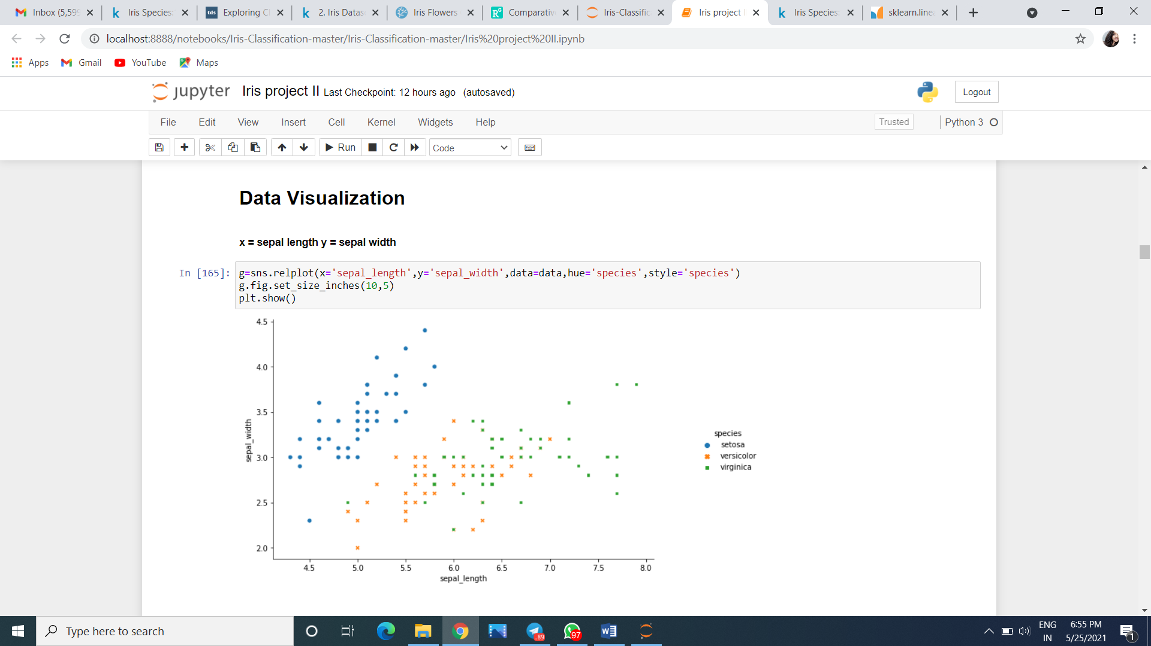 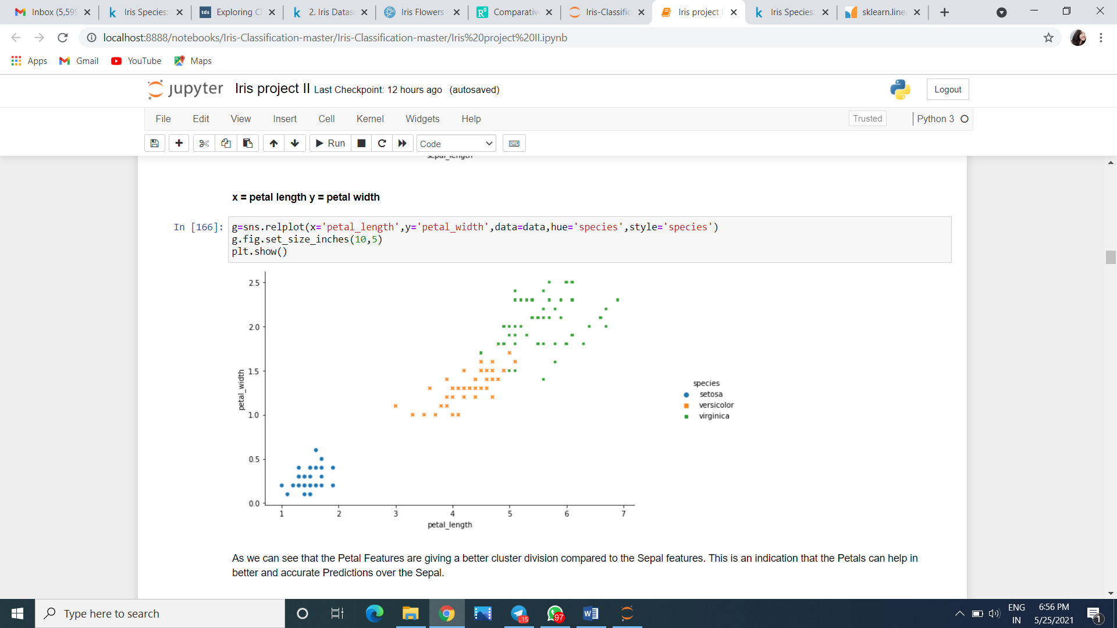 As we can see that the Petal Features are giving a better cluster division compared to the Sepal features. This is an indication that the Petals can help in better and accurate Predictions over the Sepal.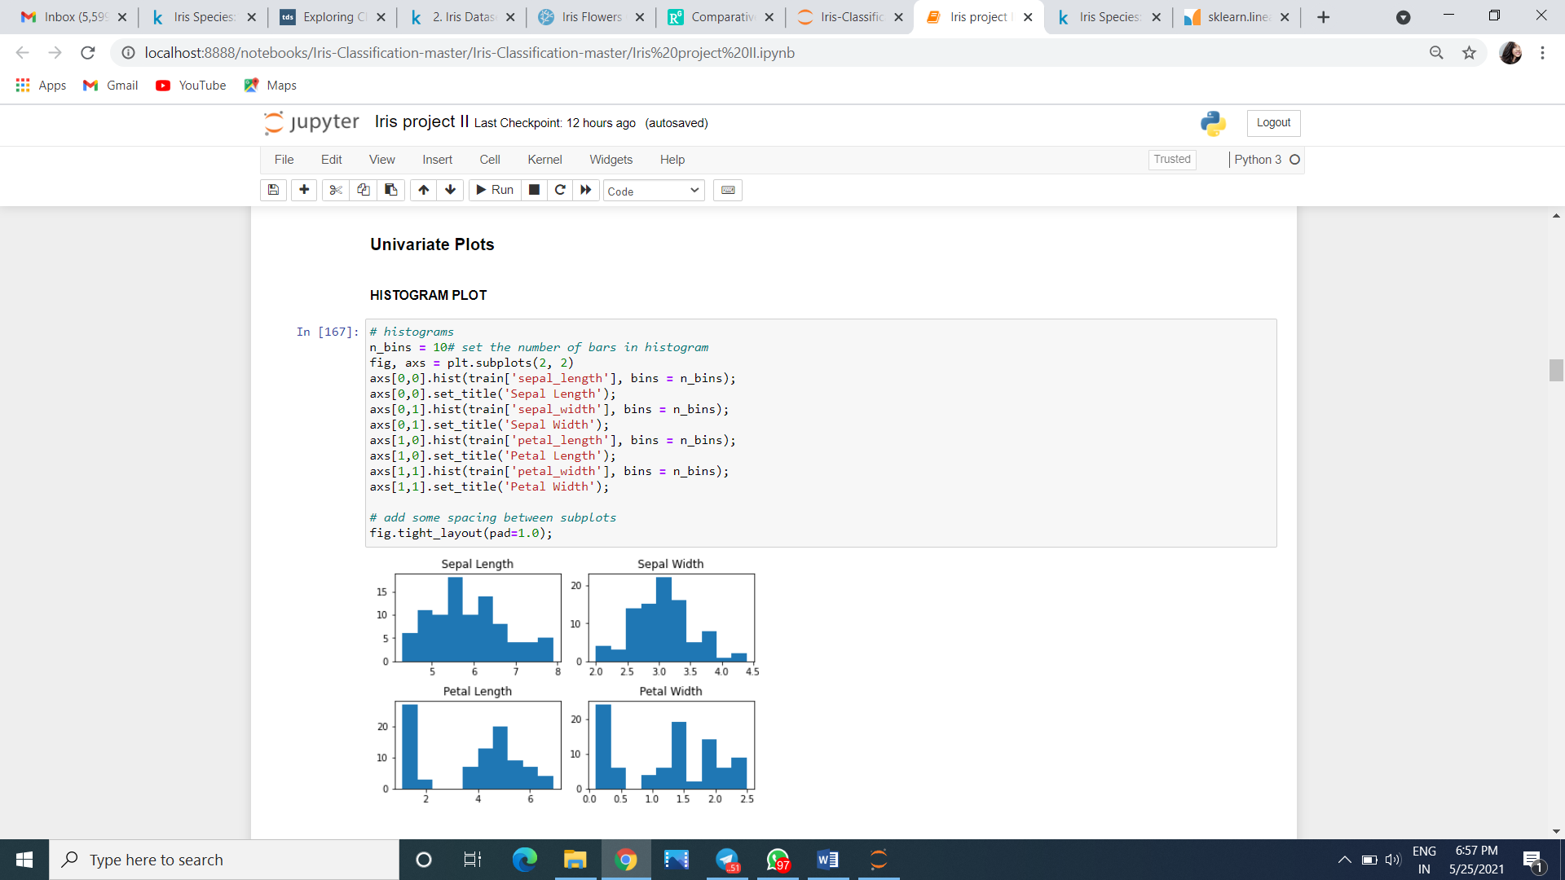 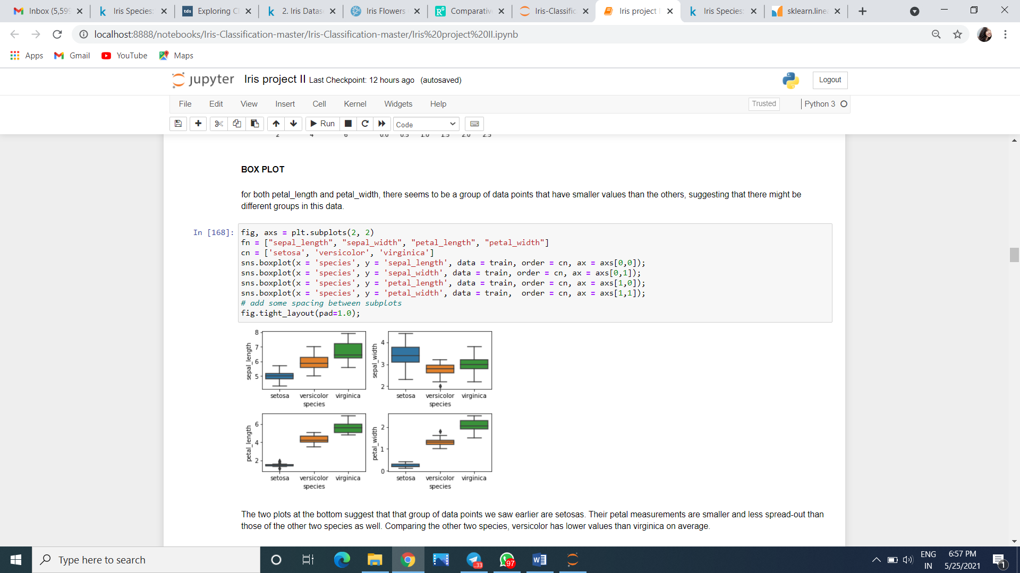 The two plots at the bottom suggest that that group of data points we saw earlier are setosas. Their petal measurements are smaller and less spread-out than those of the other two species as well. Comparing the other two species, versicolor has lower values than virginica on average.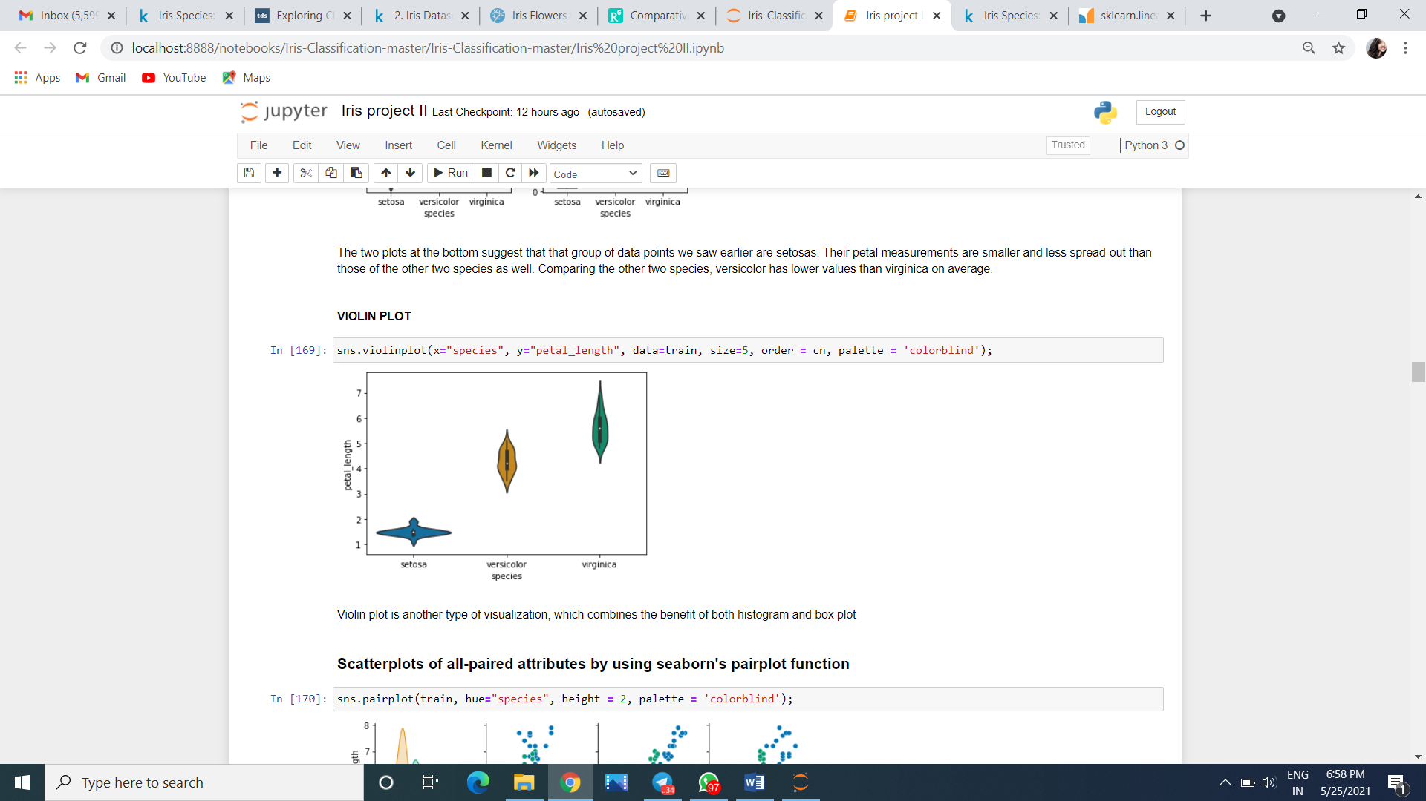

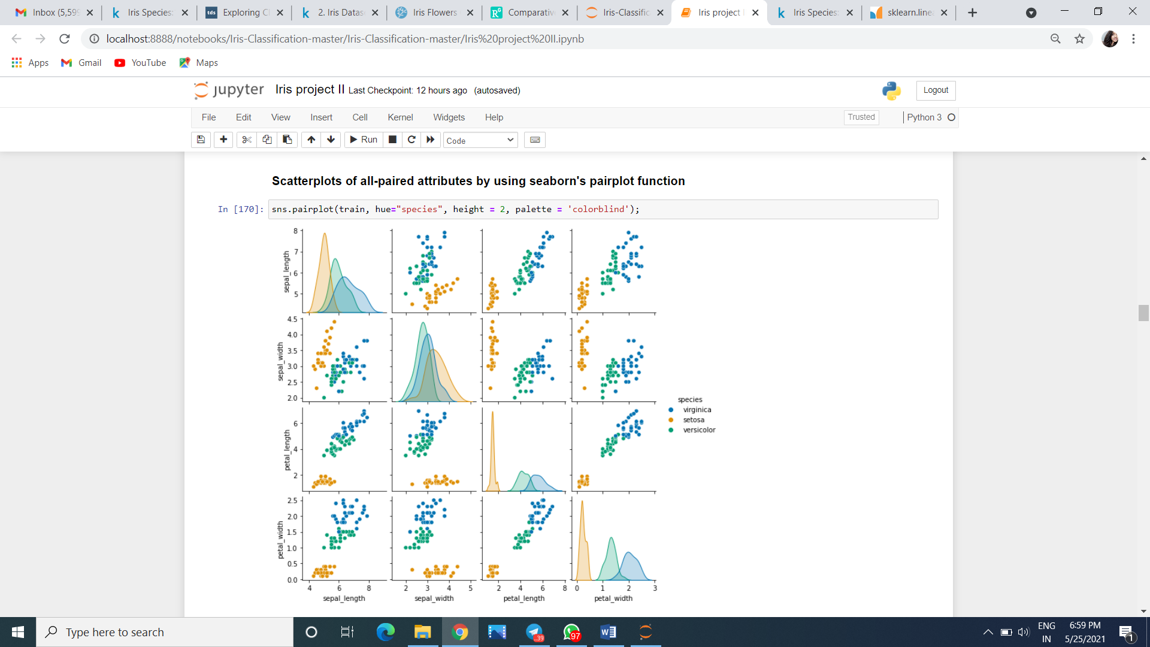 We see that some variables seem to be highly correlated, e.g. petal_length and petal_width. In addition, the petal measurements separate the different species better than the sepal ones.

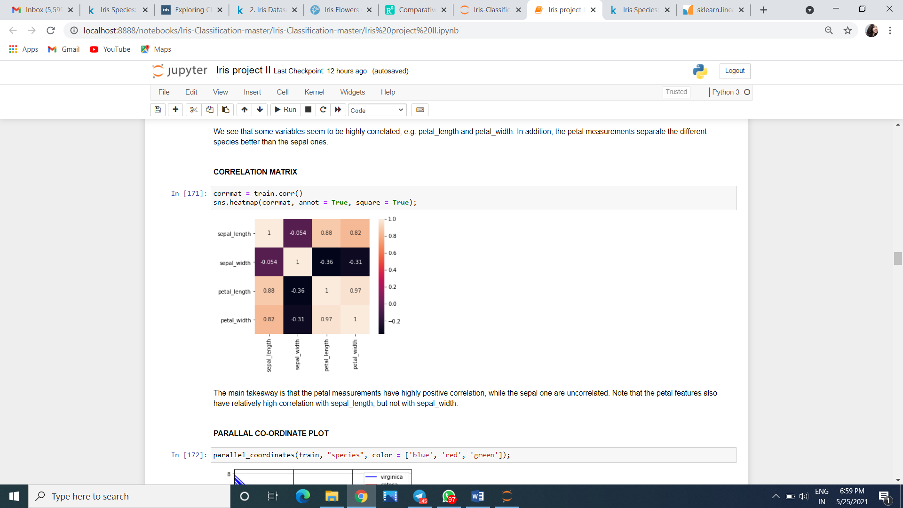

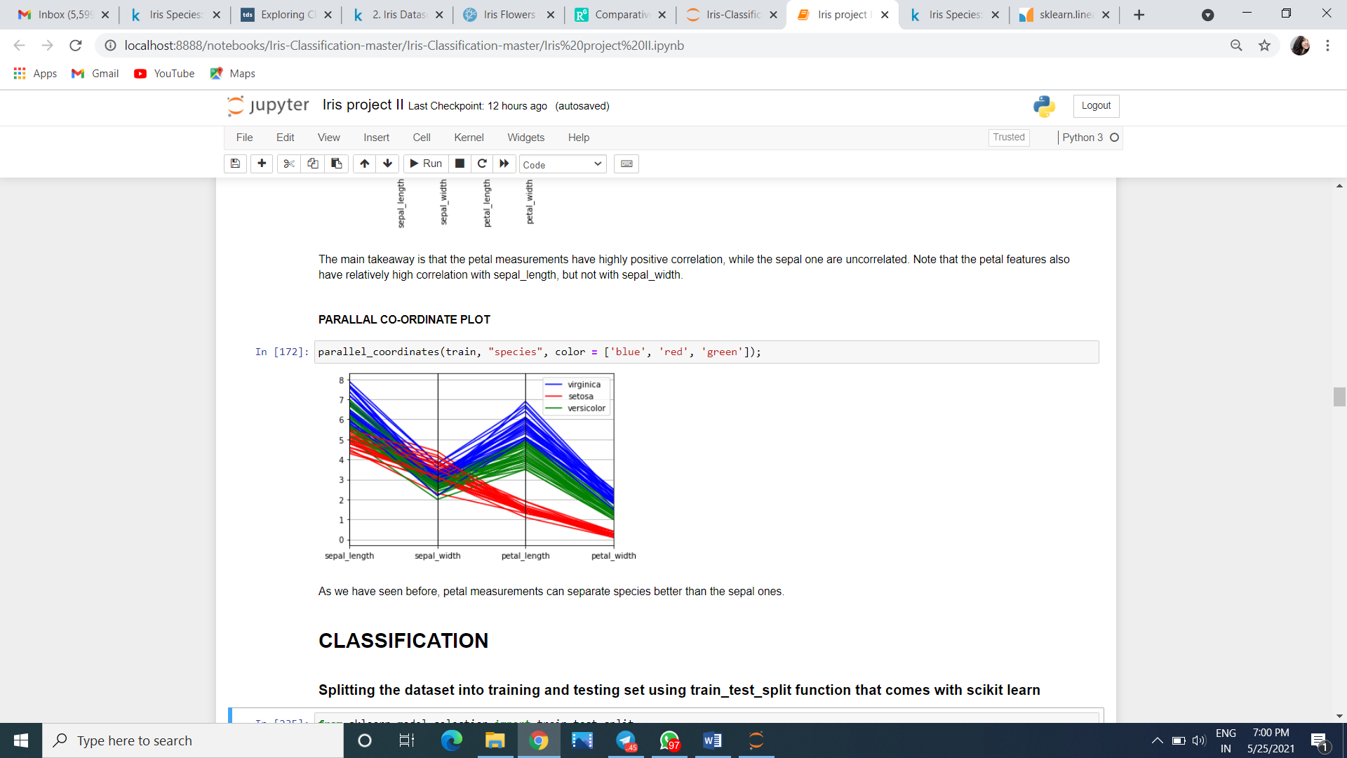

3.Build the model

We can use any classification algorithm to solve the problem.we have solved the previous problem with decision tree algorithm,I will go with that.

from sklearn import tree  
classifier=tree.DecisionTreeClassifier()

The above code will create the empty model. Inorder to provide the operations to the model we should train them.

***Note****:We can also use KNeighborsClassifier(efficiency is higher)*

from sklearn import neighbors  
classifier=neighbors.KNeighborsClassifier()

***Note****:We can also use Random Forest(efficiency is lower)*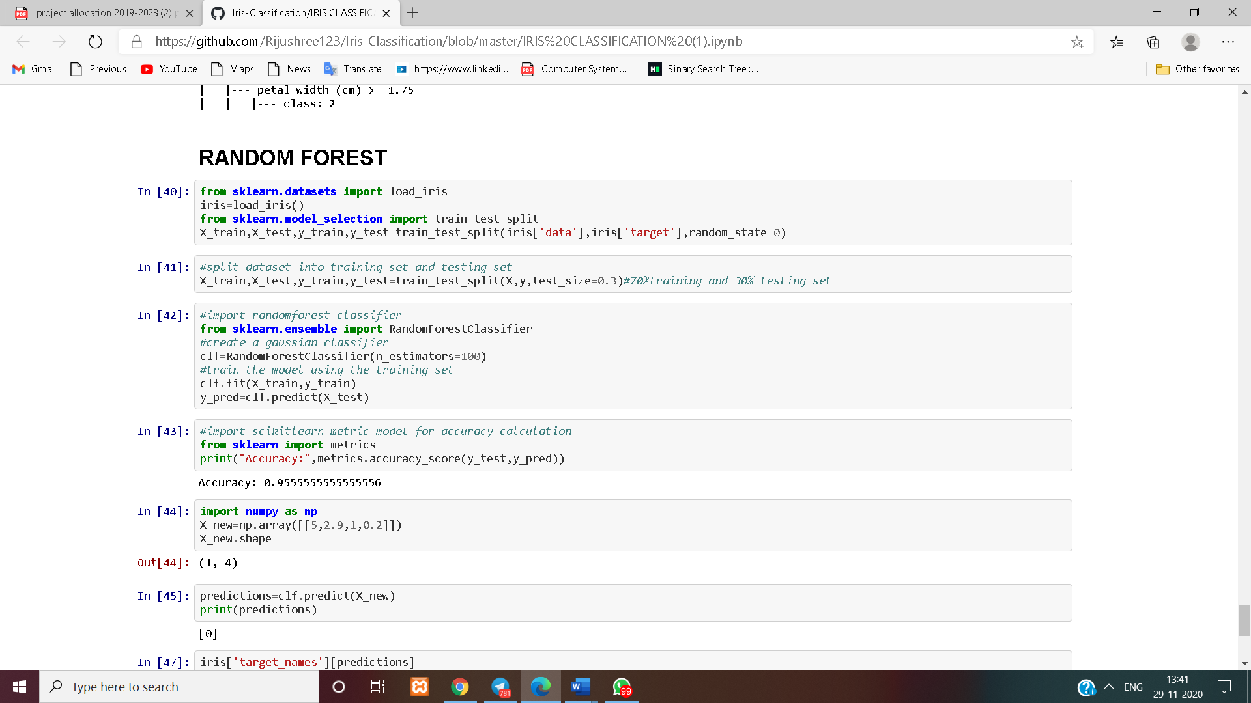

Similarly we can implement the rest of the classifiers.

At this point,We have just made the model.But it cannot able to predict whether the given flower belongs to which species of Iris .If our model has to predict the flower,We have to train the model with the Features and the Labels.

4.Train the Model.

We can train the model with ***fit***function.

classifier.fit(x_train,y_train)

Now the model is ready to make predictions

5.Make predictions:

Predictions can be done with ***predict***function

predictions=classifier.predict(x_test)

these predictions can be matched with the expected output to measure the accuracy value.

from sklearn.metrics import accuracy_score  
print(accuracy_score(y_test,predictions))

Full code(just for example not the implementation one)

from sklearn import datasets  
iris=datasets.load_iris()  
x=iris.data  
y=iris.target  
from sklearn.model_selection import train_test_split  
x_train,x_test,y_train,y_test=train_test_split(x,y,test_size=.5)  
from sklearn import tree  
classifier=tree.DecisionTreeClassifier()  
classifier.fit(x_train,y_train)  
predictions=classifier.predict(x_test)  
from sklearn.metrics import accuracy_score  
print(accuracy_score(y_test,predictions))

Output:

D:\iris_classification>python classifier.py  
0.96

So the accuracy is 96%

This is just an example.

Of course the accuracy will differ as we implement other classifiers .

At the end we will analyse which classifier is the best for this dataset.

# EXPERIMENTAL SETUP AND RESULT ANALYSIS

**SETUP**

**Things we need to download and install:**

* **Anaconda**
* **Jupyter notebook**

**Importing the libraries**

First of all, let’s import the modules as listed above:

* **SkLearn** is a pack of Python modules built for data science applications (which includes machine learning). Here, we’ll be using three particular modules:
* **load**_**iris**: The classic dataset for the iris classification problem. (NumPy array)
* **train**_**test**_**split**: method for splitting our dataset.
* **KNeighborsClassifier**: method for classifying using the K-Nearest Neighbor approach.
* **NumPy** is a Python library that makes it easier to work with N-dimensional arrays and has a large collection of mathematical functions at its disposal. It’s’ base data type is the “numpy.ndarray”.
* **pandas** **Pandas** is a high-level data manipulation tool developed by Wes McKinney. It is built on the Numpy package and its key data structure is called the DataFrame. DataFrames allow you to store and manipulate tabular data in rows of observations and columns of variables.
* **matplotlib** Matplotlib is a plotting library for the Python programming language and its numerical mathematics extension NumPy. It provides an object-oriented API for embedding plots into applications using general-purpose GUI toolkits like Tkinter, wxPython, Qt, or GTK+. ... SciPy makes use of Matplotlib.
* **DecisionTreeClassifier** Decision Trees (DTs) are a non-parametric supervised learning method used for classification and regression.
* **RandomForestClassifier** has multiple decision trees as base learning models.
* **metrics** metrics module implements several loss, score, and utility functions to measure classification performance.
* **LogisticRegression**module used to implement logistic regression
* **LinearSVC**module used to implement linear support vector machine classification
* **GaussianNB** module used to implement Gaussian naïve bayes
* **LDA** module used to implement linear discriminant analysis

**RESULT ANALYSIS 1**

**K-Nearest Neighbor:-**

K-Nearest Neighbour is one of the simplest Machine Learning algorithms based on Supervised Learning technique.

K-NN algorithm assumes the similarity between the new case/data and available cases and put the new case into the category that is most similar to the available categories.

K-NN algorithm stores all the available data and classifies a new data point based on the similarity. This means when new data appears then it can be easily classified into a well suite category by using K- NN algorithm.

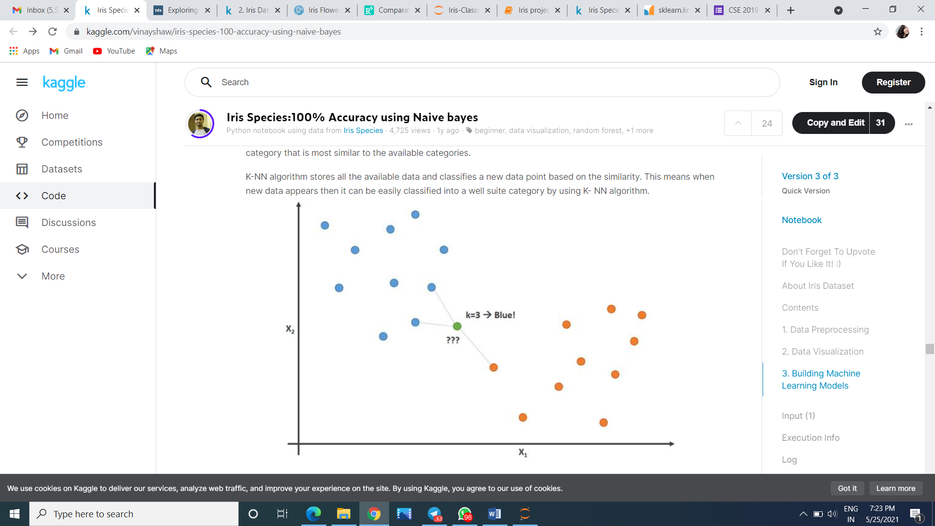

**Now our model :**

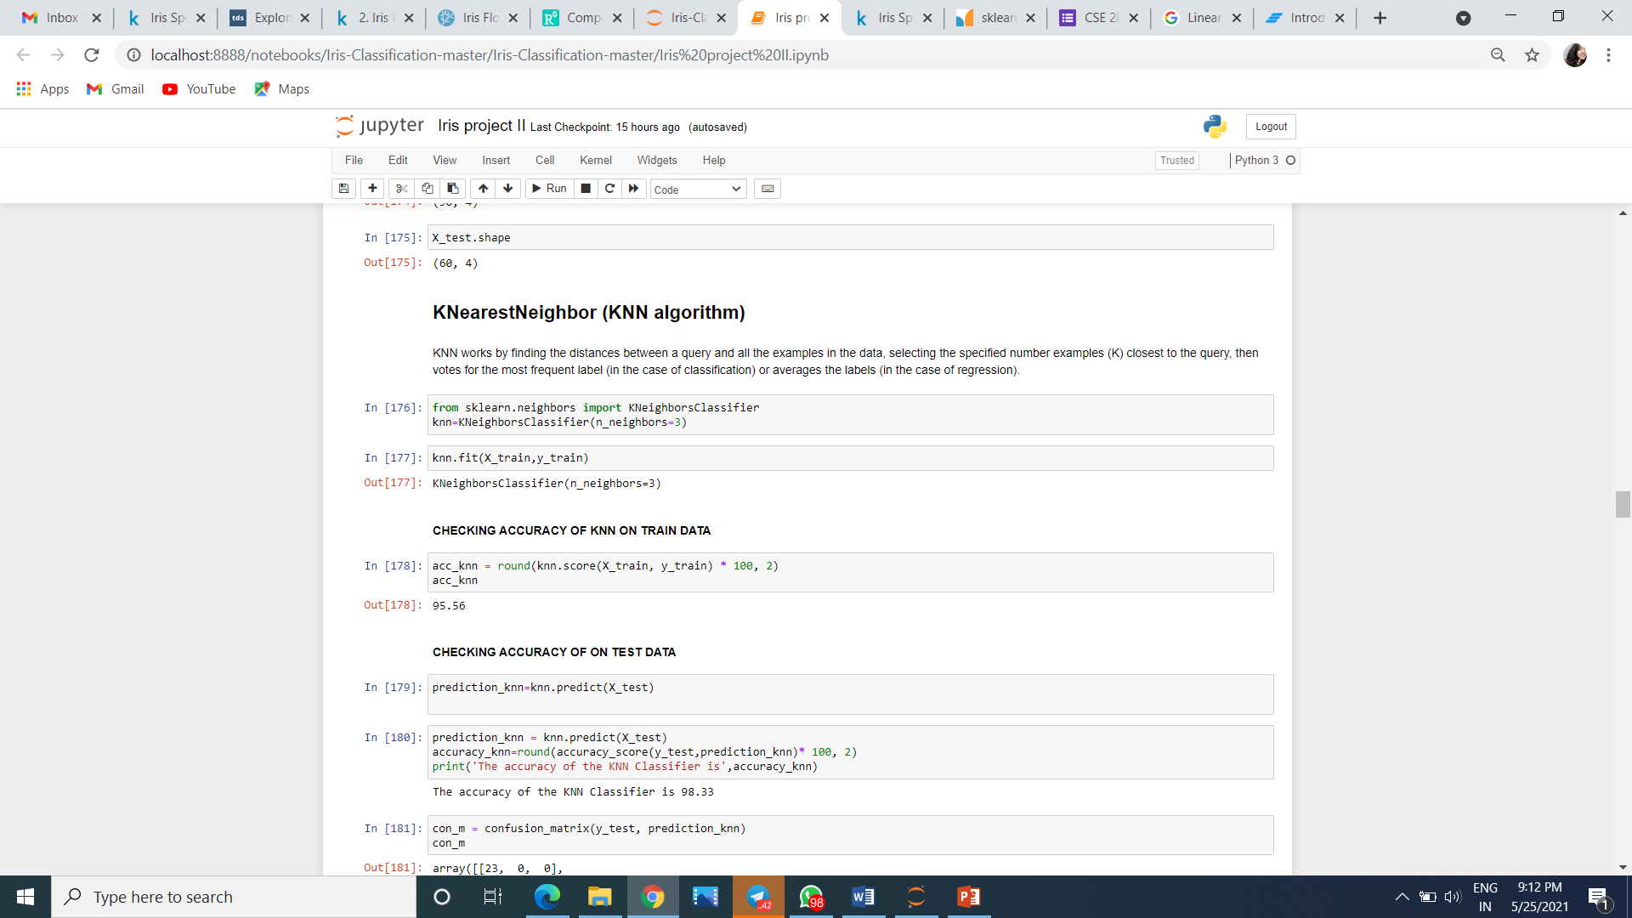

* Here we have taken unknown sepal length,sepal width,petal length,petal width:

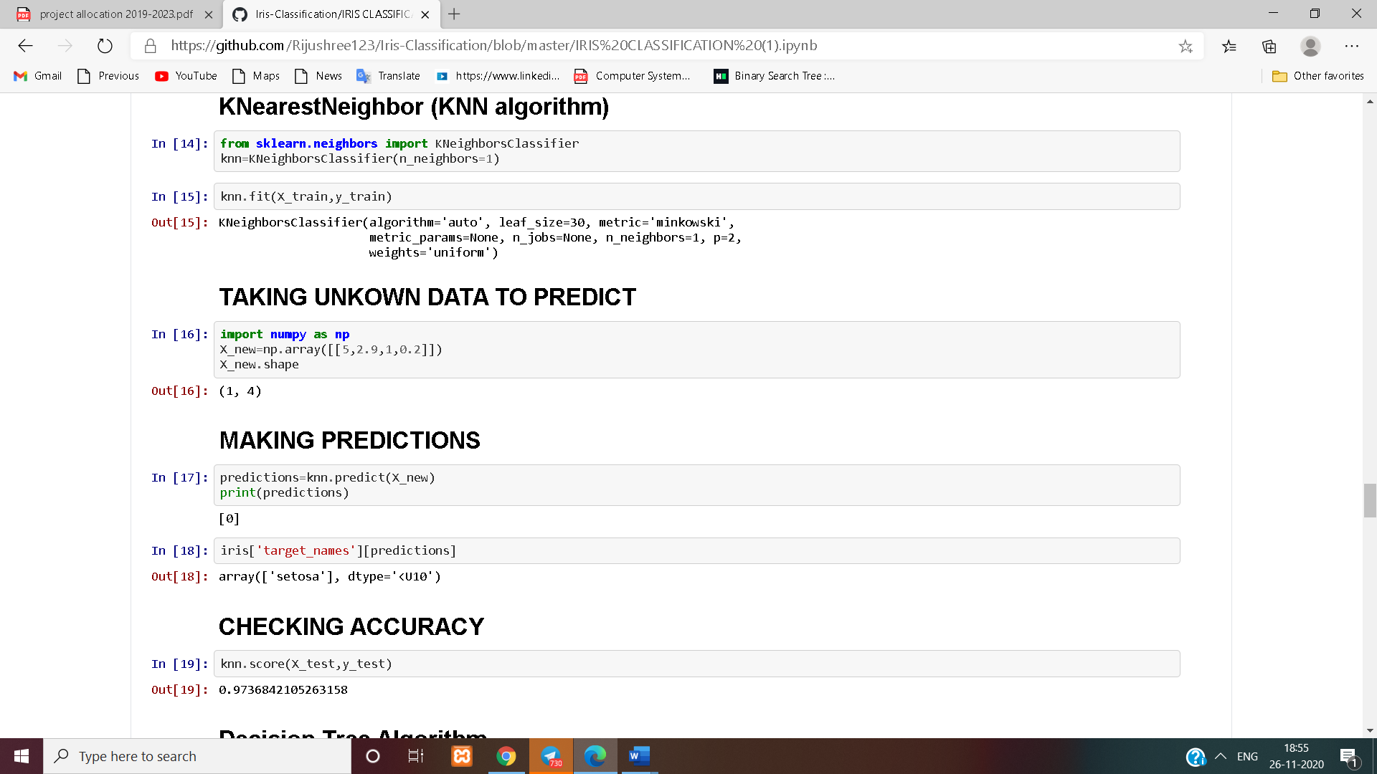

* As per the data the prediction output came as [0] shown below:



* To see actually which species is in coded form as [0] we use the target attribute :



* To see how much accurate is our prediction model we check the accuracy below:
* 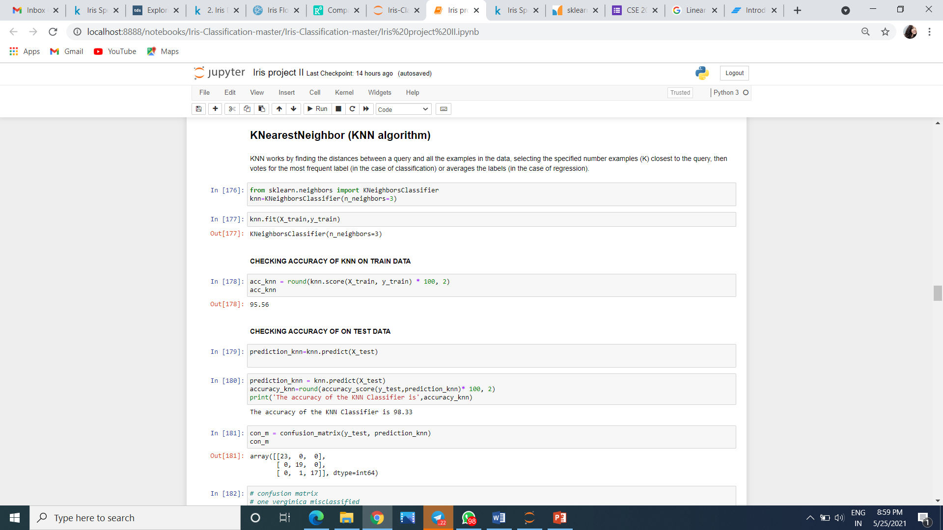

**RESULT ANALYSIS 2**

**Decision Tree Algorithm:-**

A decision tree is a flowchart-like structure in which each internal node represents a test on a feature (e.g. whether a coin flip comes up heads or tails) , each leaf node represents a class label (decision taken after computing all features) and branches represent conjunctions of features that lead to those class labels. The paths from root to leaf represent classification rules. Inbjb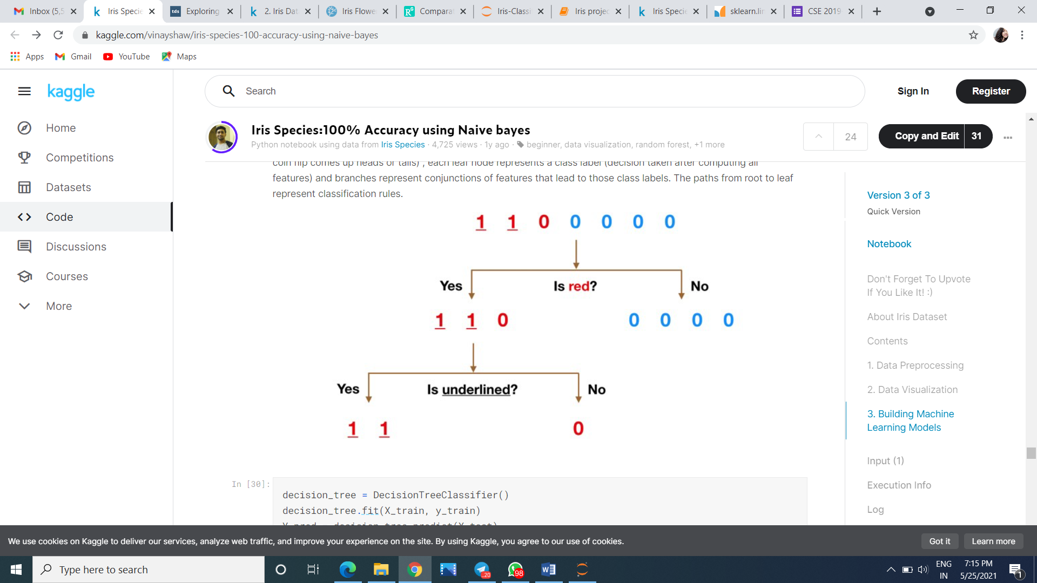

In our case:

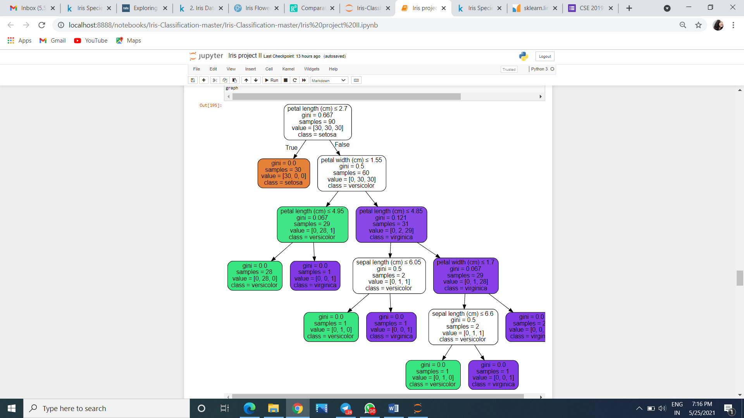

**Now our model :**

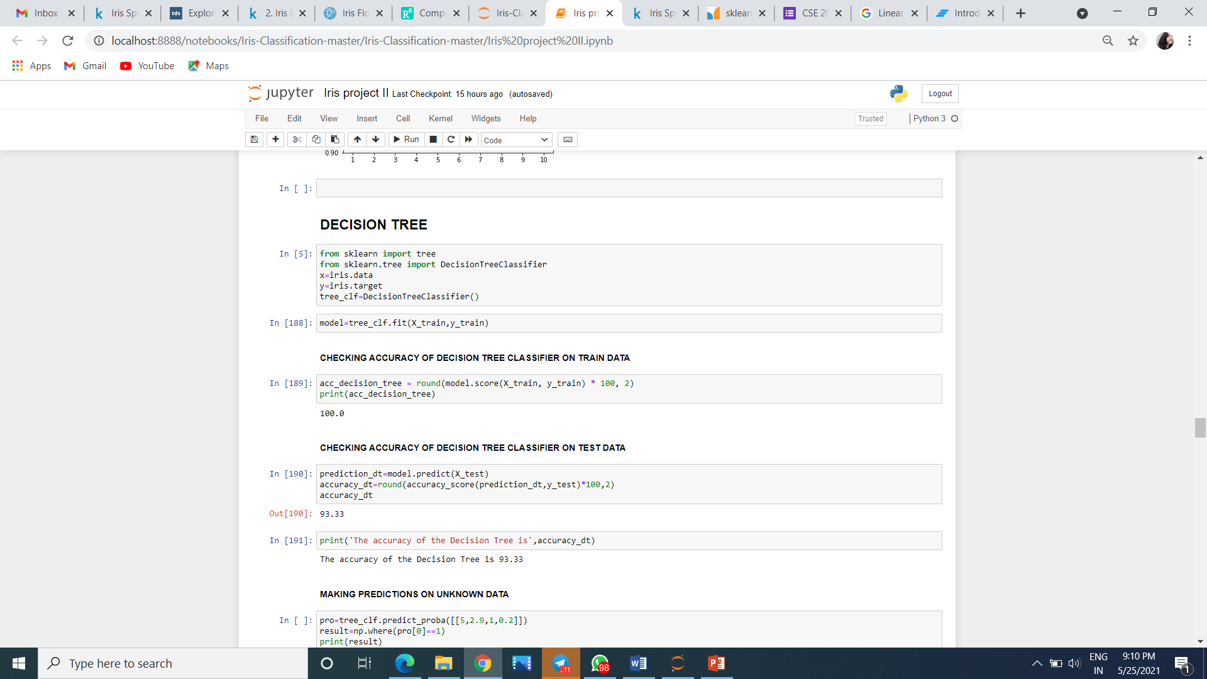

* To see how much accurate is our prediction model we check the accuracy below:

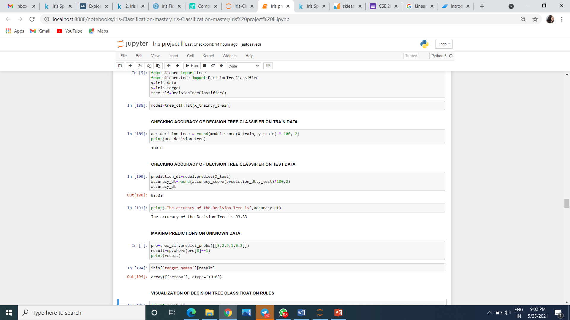

* Here we have taken unkown sepal length sepal width,petal length,petal width as:



**RESULT ANALYSIS 3**

**Random Forest:-**

Random forest, like its name implies, consists of a large number of individual decision trees that operate as an ensemble. Each individual tree in the random forest spits out a class prediction and the class with the most votes becomes our model’s prediction.

A large number of relatively uncorrelated models (trees) operating as a committee will outperform any of the individual constituent models.

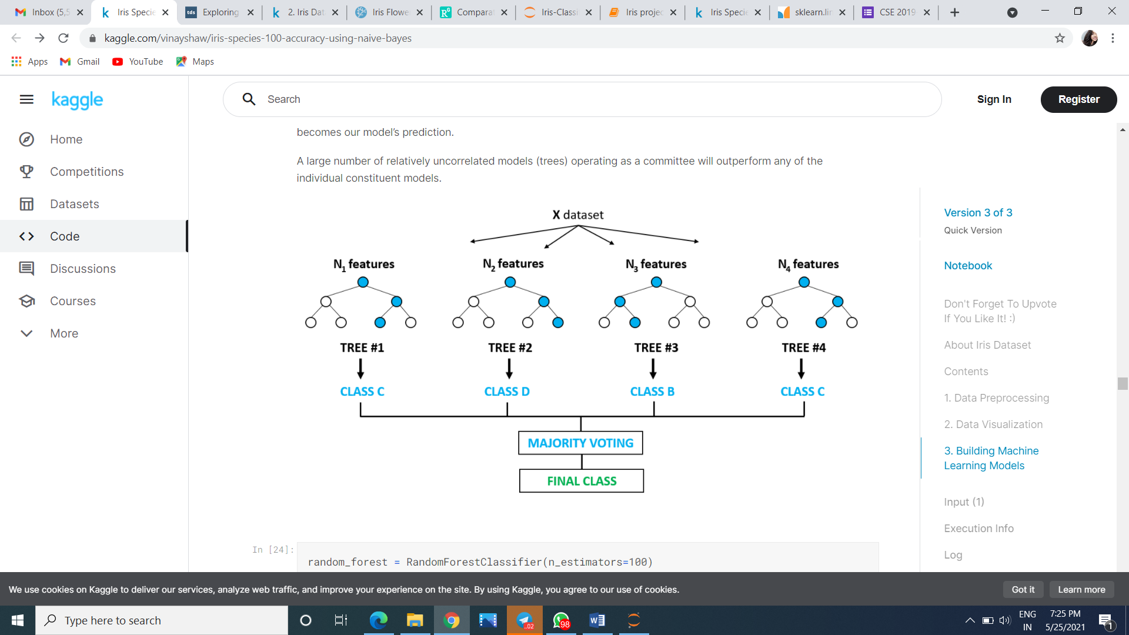

**Now our model :**

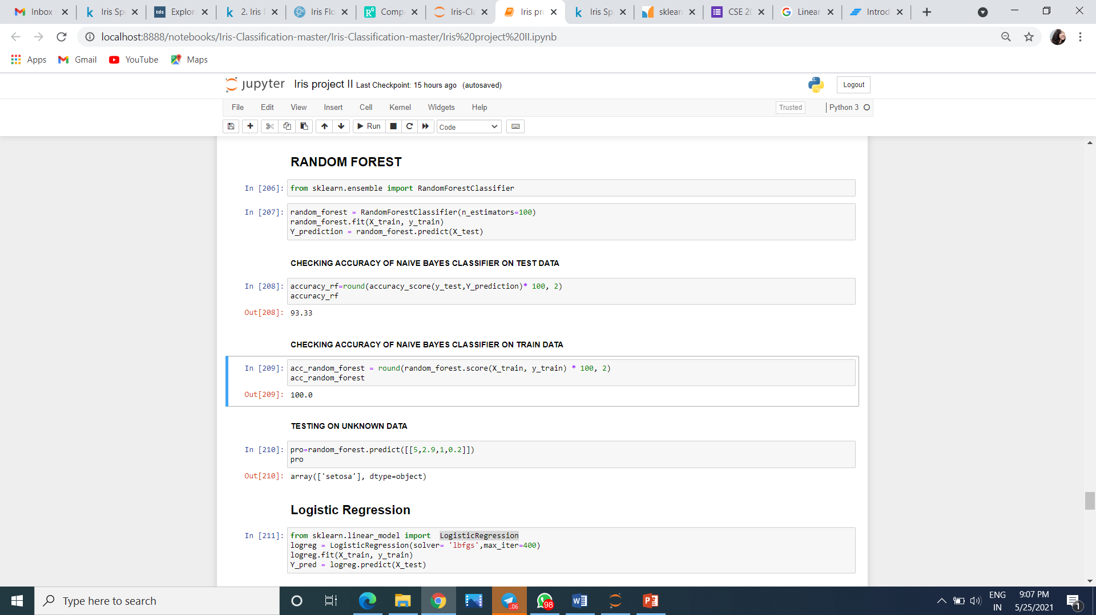

* To see how much accurate is our prediction model we check the accuracy below:

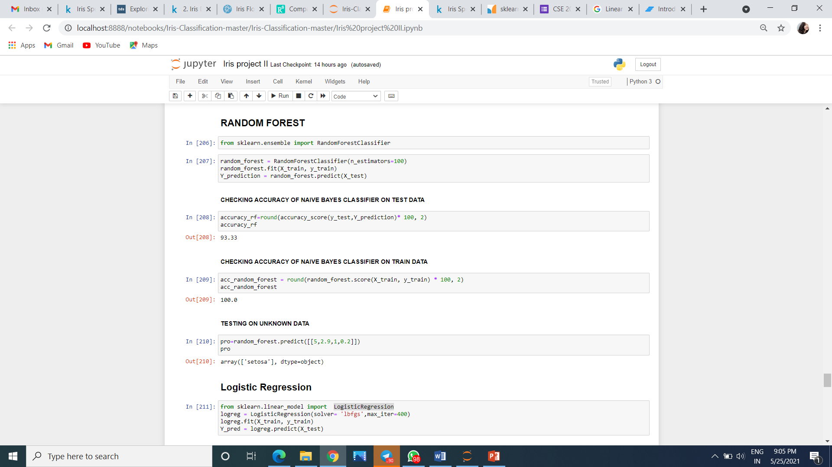

* Here we have taken unkown sepal length sepal width,petal length,petal width as: 

**RESULT ANALYSIS 4**

**Naive Bayes:-**

Naive Bayes is a classification algorithm for binary (two-class) and multi-class classification problems. The technique is easiest to understand when described using binary or categorical input values.

It is called naive Bayes or idiot Bayes because the calculation of the probabilities for each hypothesis are simplified to make their calculation tractable. Rather than attempting to calculate the values of each attribute value P(d1, d2, d3|h), they are assumed to be conditionally independent given the target value and calculated as P(d1|h) * P(d2|H) and so on.

This is a very strong assumption that is most unlikely in real data, i.e. that the attributes do not interact. Nevertheless, the approach performs surprisingly well on data where this assumption does not hold.

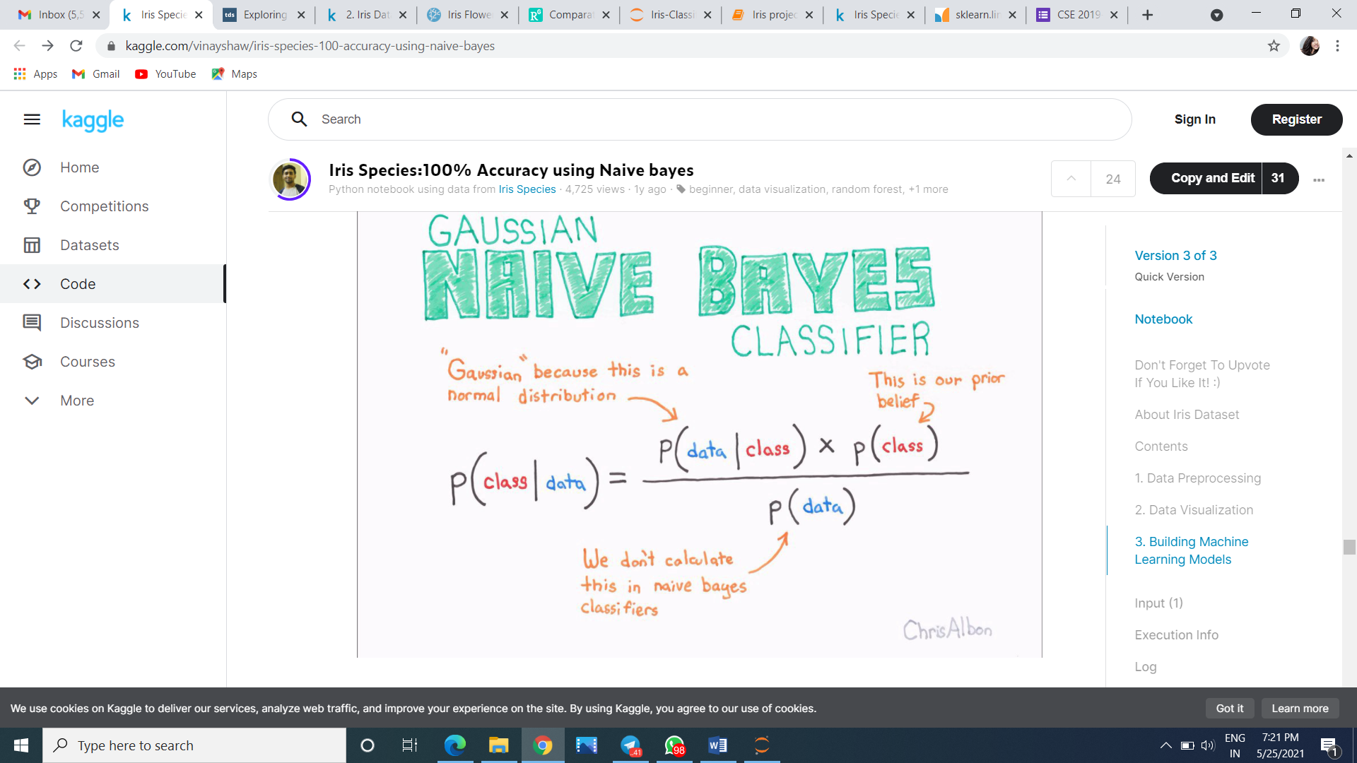

**Now our model :**

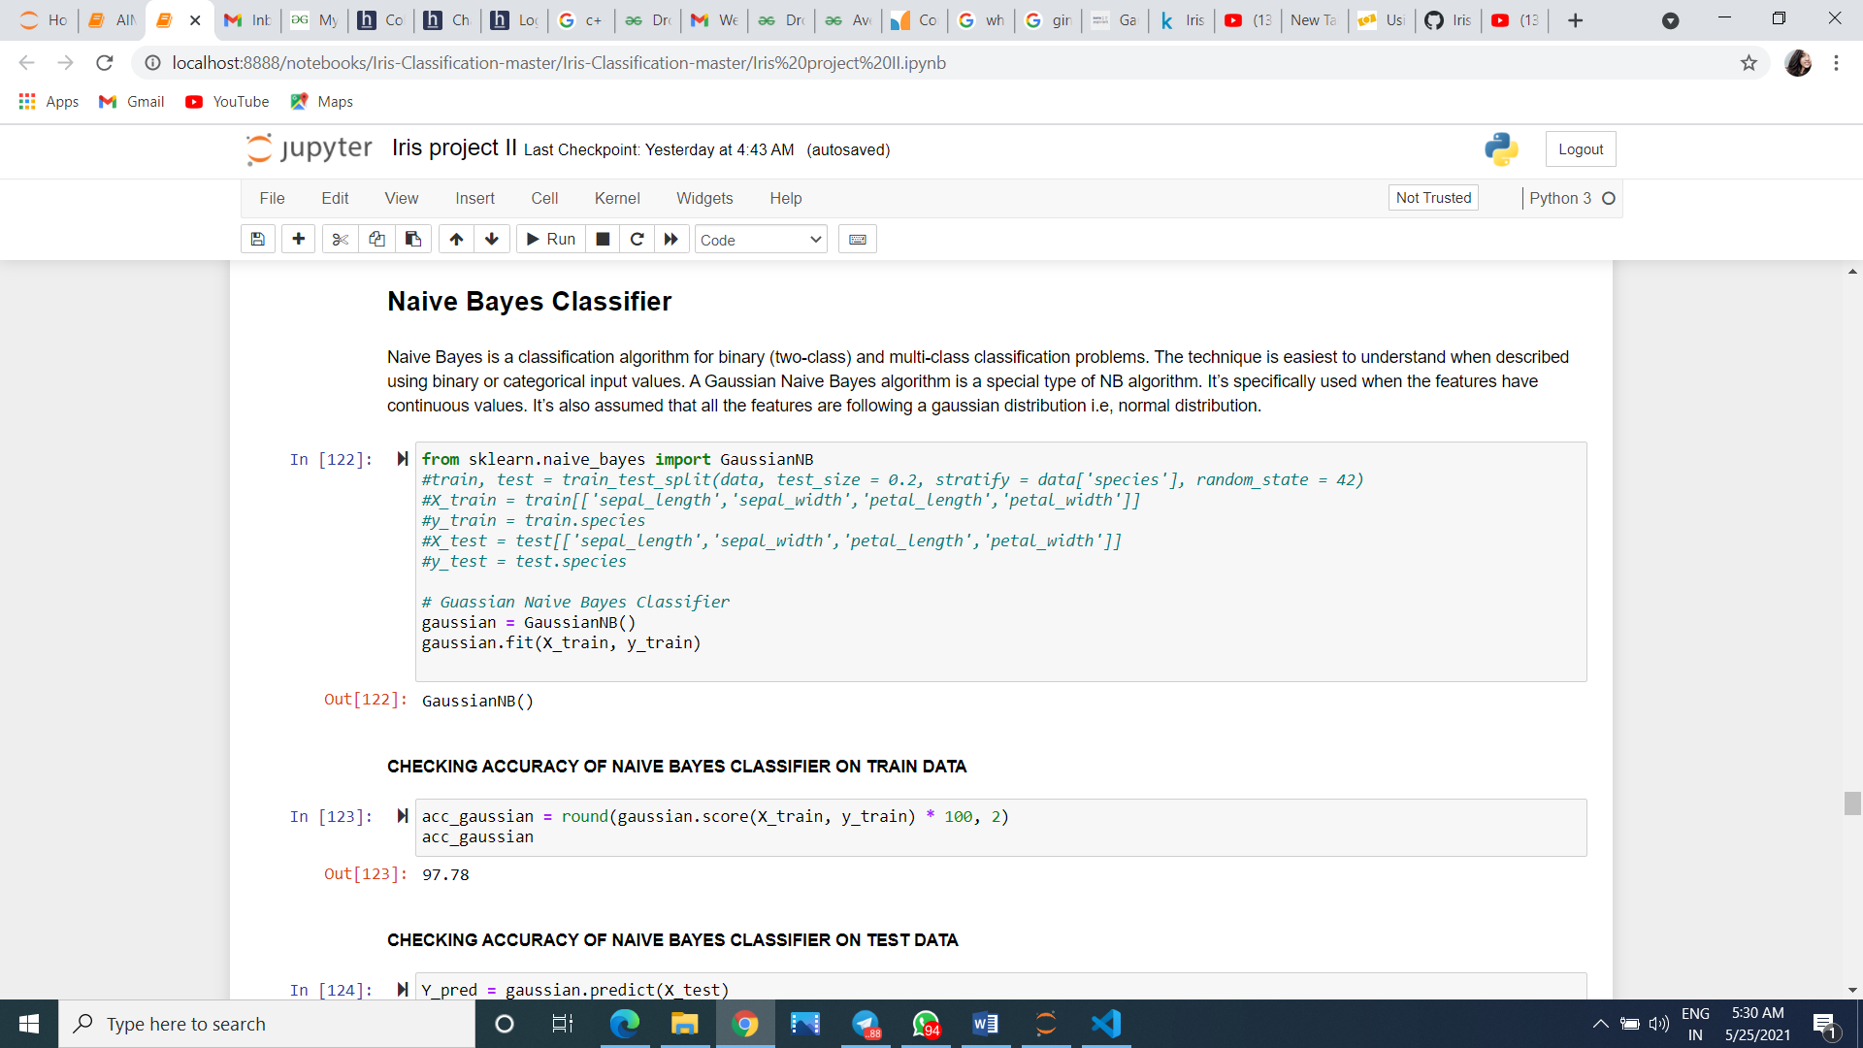

* To see how much accurate is our prediction model we check the accuracy below:
  + 
  + We can see the accuracy score on train data is 97% approx.

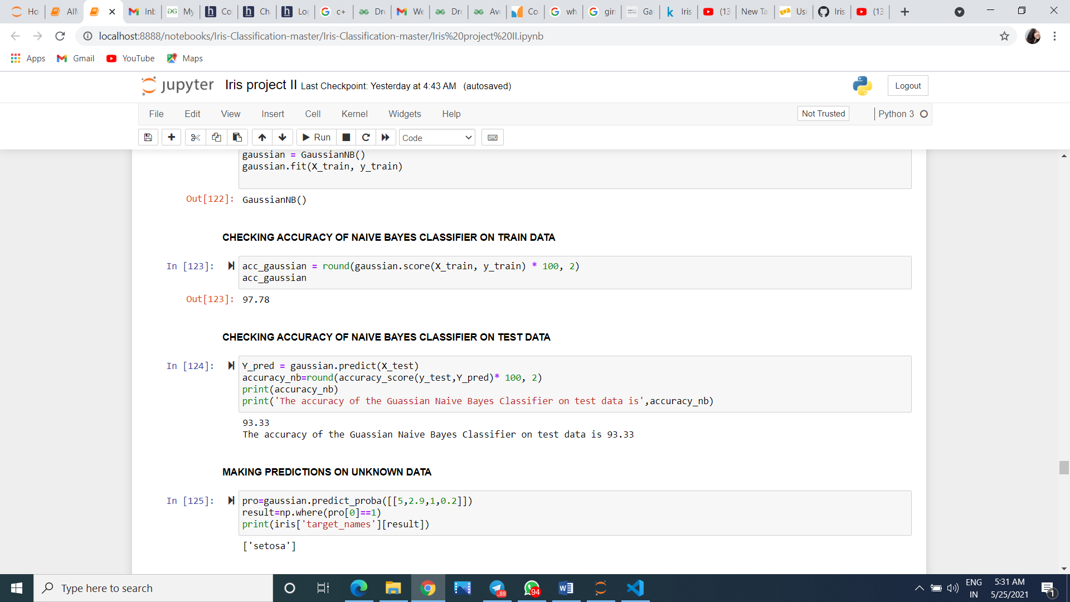

* Here we have taken unknown sepal length,sepal width,petal length,petal width:



**RESULT ANALYSIS 5**

**Logistic Regression:-**

Logistic Regression is a Machine Learning algorithm which is used for the classification problems, it is a predictive analysis algorithm and based on the concept of probability.

We can call a Logistic Regression a Linear Regression model but the Logistic Regression uses a more complex cost function, this cost function can be defined as the ‘Sigmoid function’ or also known as the ‘logistic function’ instead of a linear function.

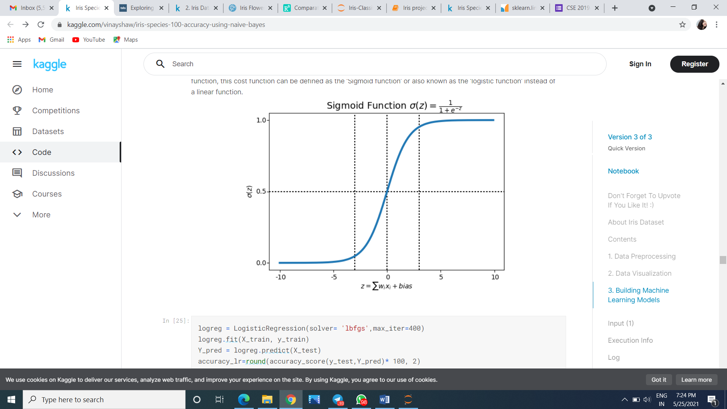

**Now our model :**

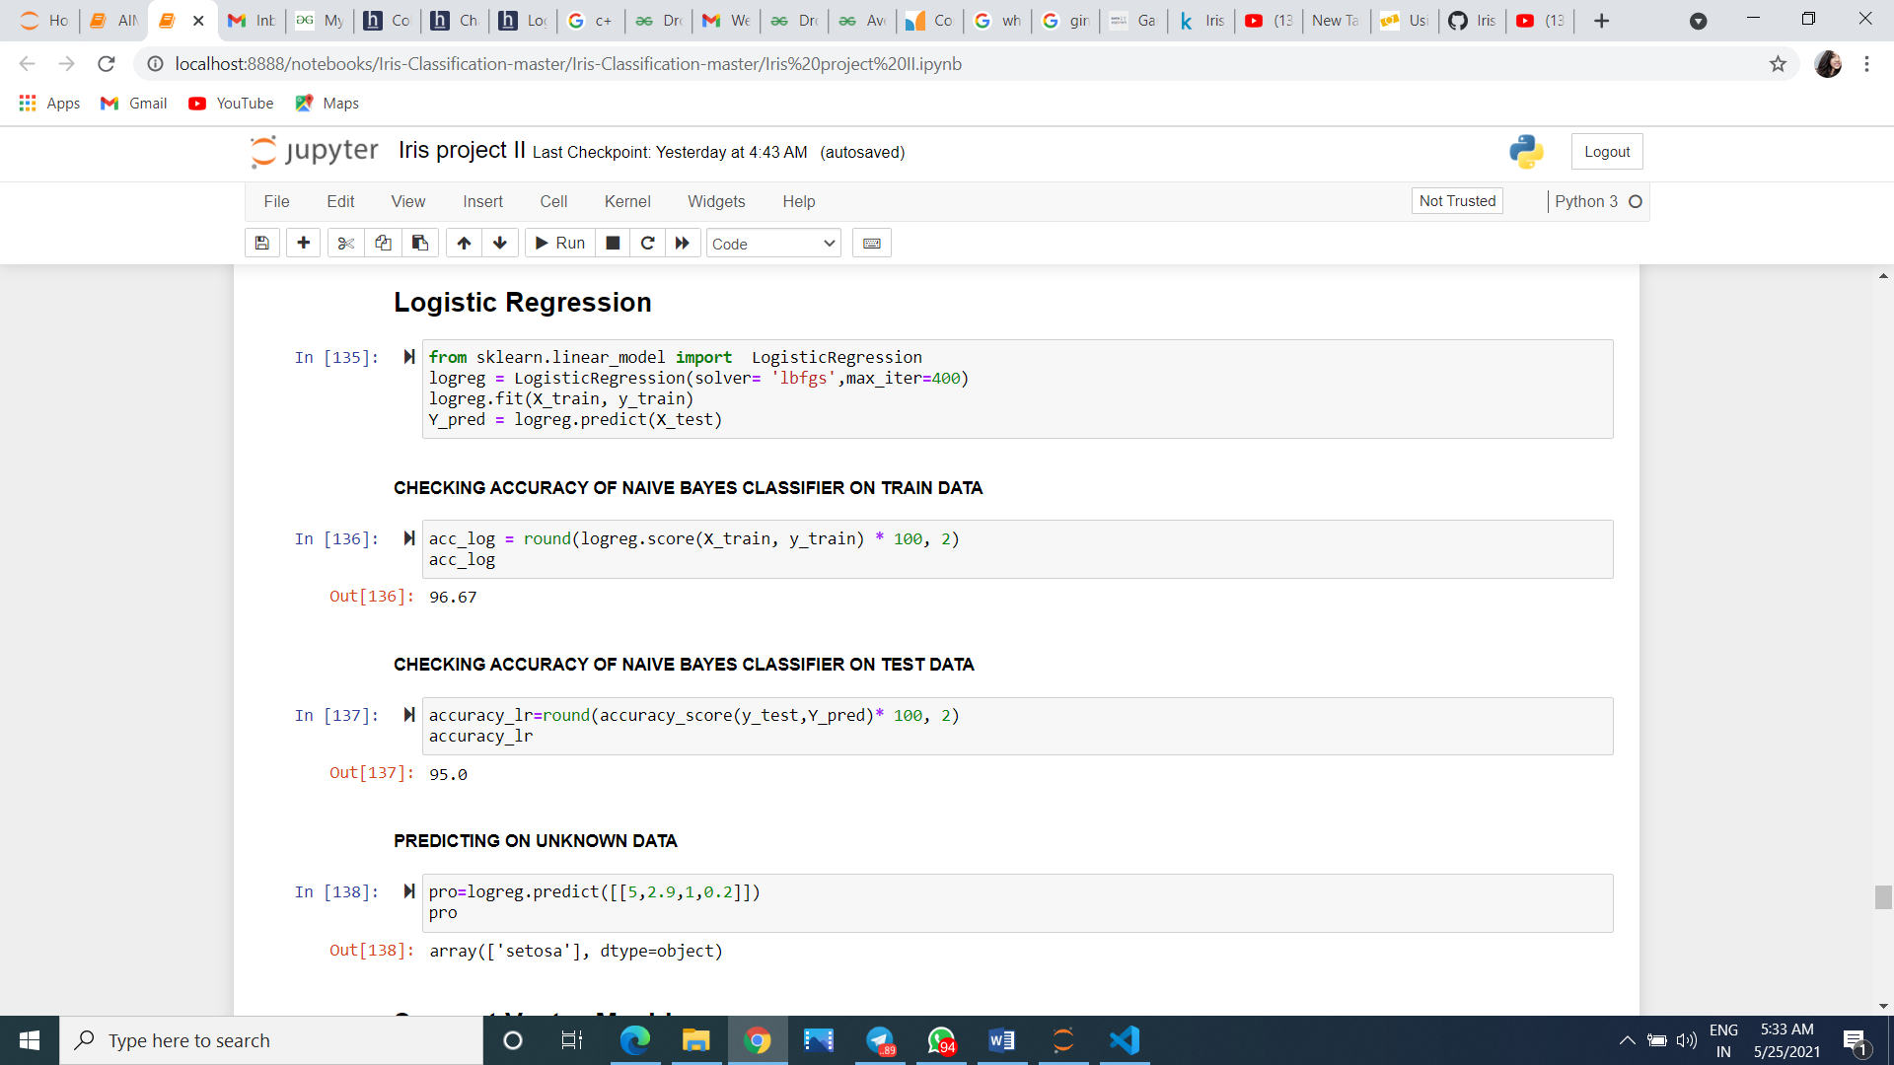

* To see how much accurate is our prediction model we check the accuracy below: 

Here we can see that the accuracy score on train data is 96.67 % and on test data is 95%

* Here we have taken unknown sepal length,sepal width,petal length,petal width:

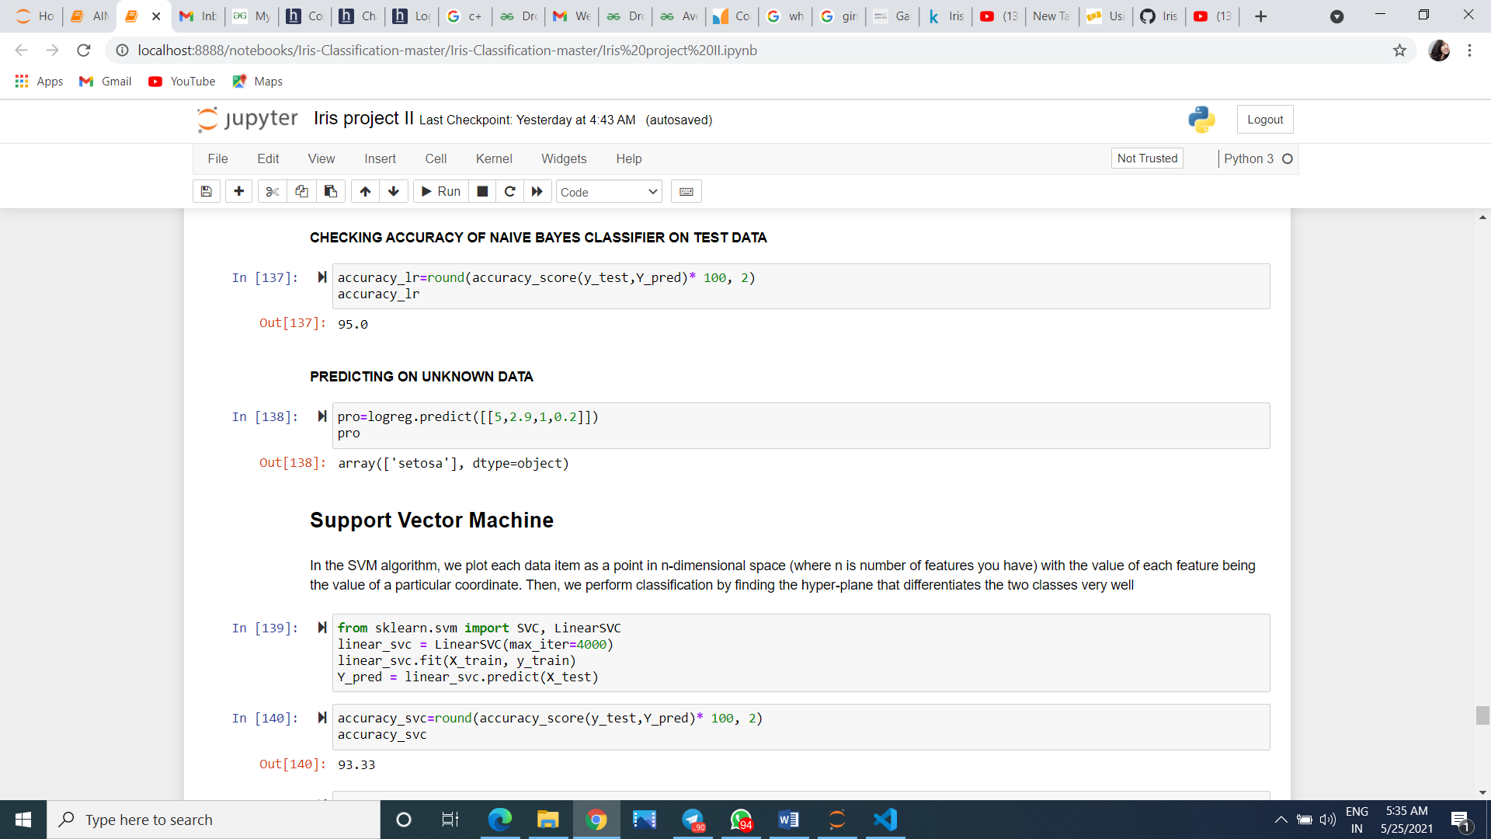

**RESULT ANALYSIS 6**

**Linear Discriminant Analysis:-**

If we use multivariate Gaussian distribution to calculate the class conditional density instead of taking a product of univariate Gaussian distribution (used in Naive Bayes), we would then get a LDA model (read more here). The key assumption of LDA is that the covariances are equal among classes. We can examine the test accuracy using all features and only petal features:

To visualize the decision boundary in 2D, we can use our LDA model with only petals and also plot the test data:

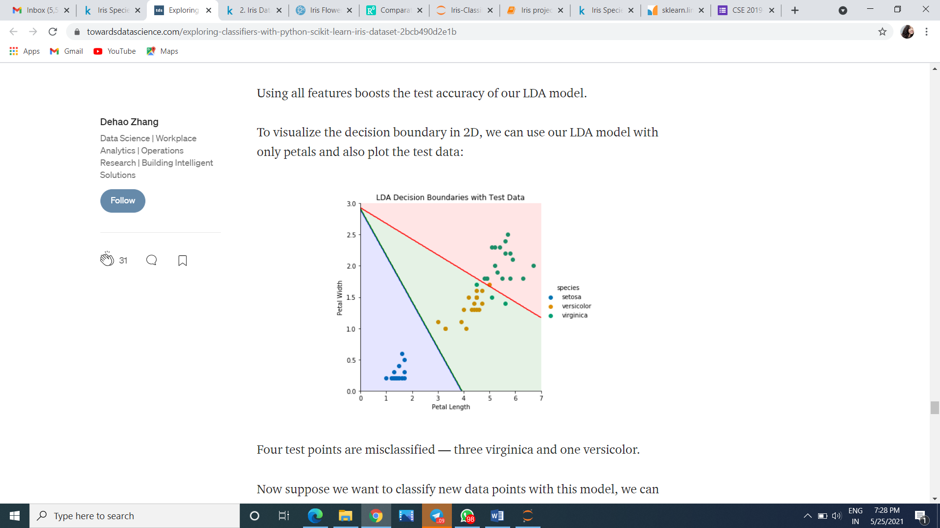

**Now our model :**

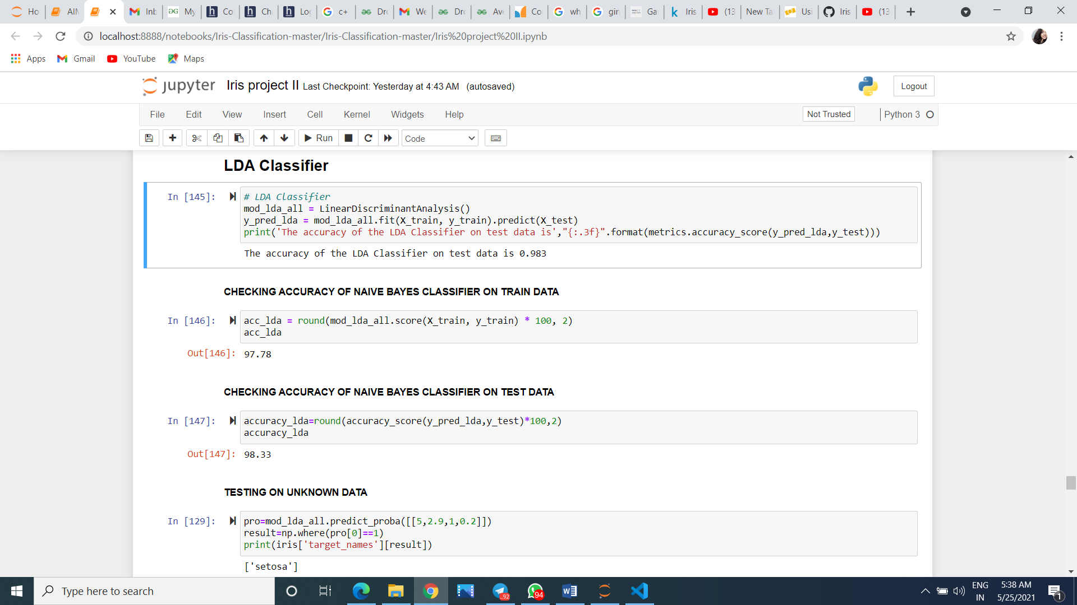

* To see how much accurate is our prediction model we check the accuracy below:

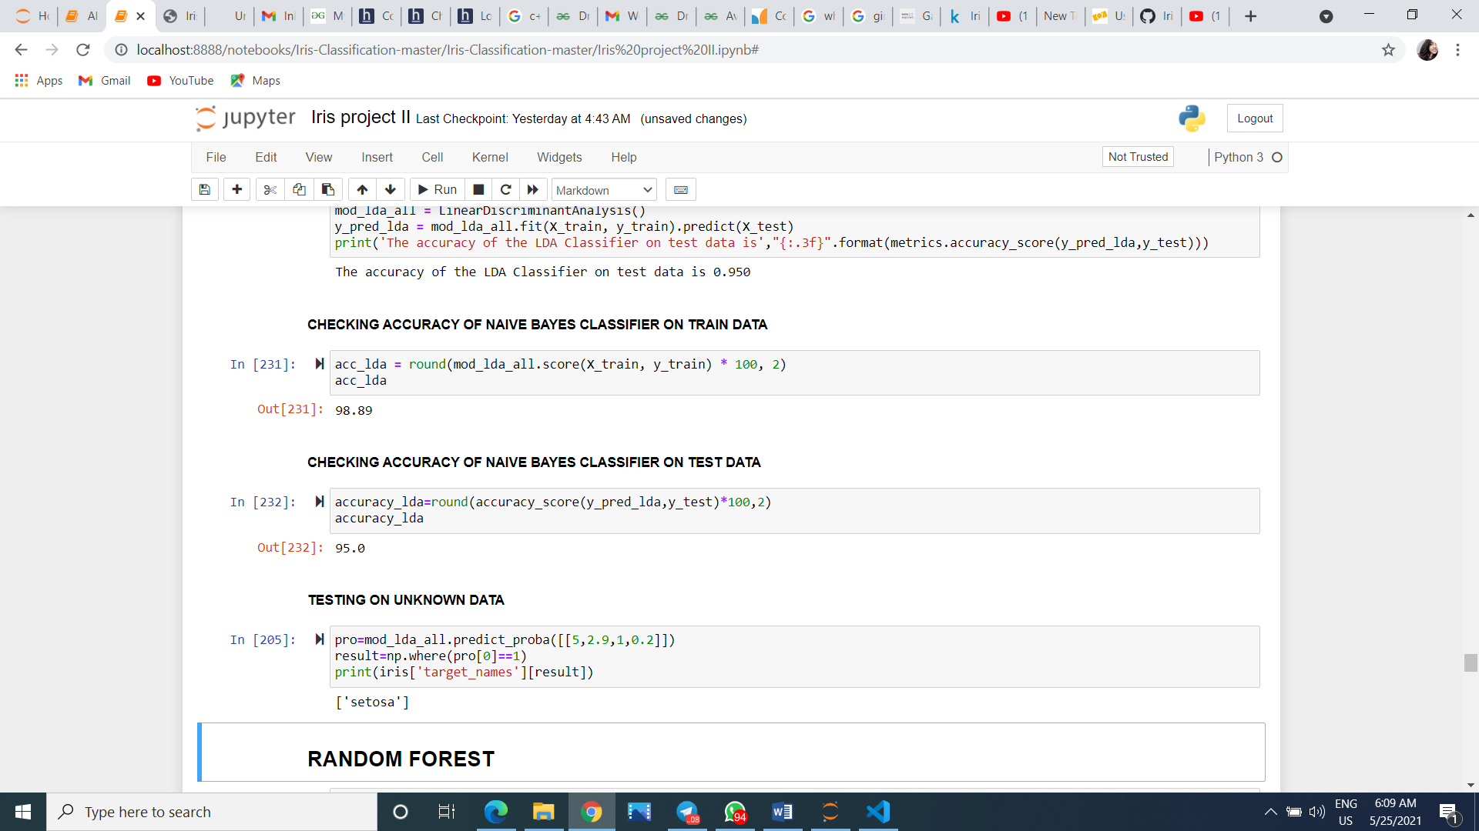

So here we can see accuracy score on test data is better than train data

* Here we have taken unknown sepal length,sepal width,petal length,petal width:



**RESULT ANALYSIS 7**

**Linear Support Vector Machine:-**

Support Vector Machine” (SVM) is a supervised machine learning algorithm which can be used for both classification or regression challenges. However, it is mostly used in classification problems. In the SVM algorithm, we plot each data item as a point in n-dimensional space (where n is number of features you have) with the value of each feature being the value of a particular coordinate. Then, we perform classification by finding the hyper-plane that differentiates the two classes very well

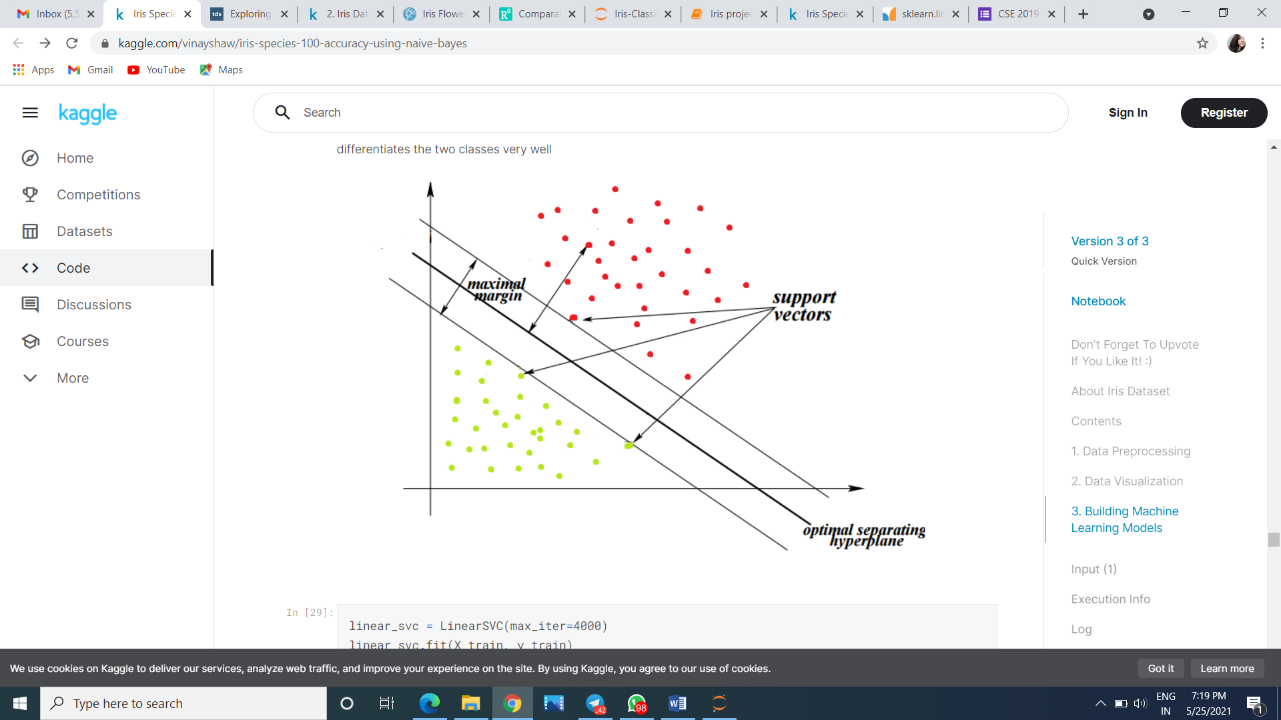

**Now our model :**

* 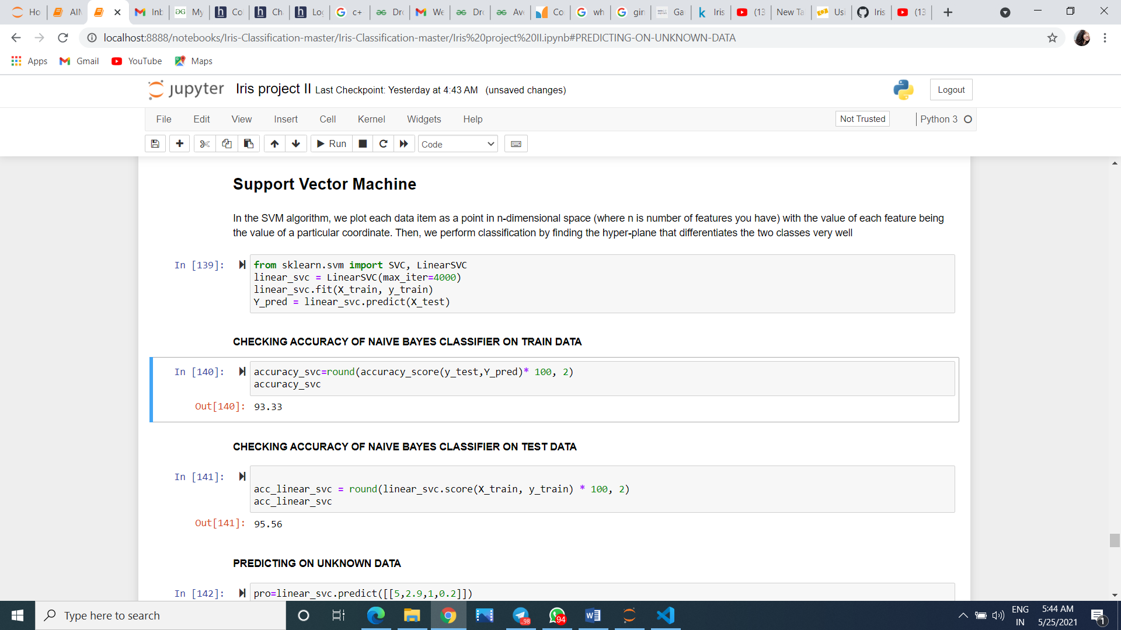 To see how much accurate is our prediction model we check the accuracy below:





* Here we have taken unknown sepal length,sepal width,petal length,petal width:

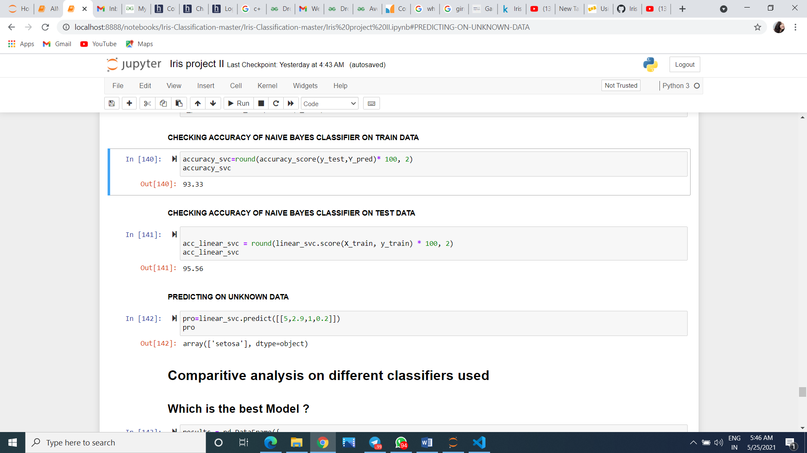

**COMPARATVE ANALYSIS**

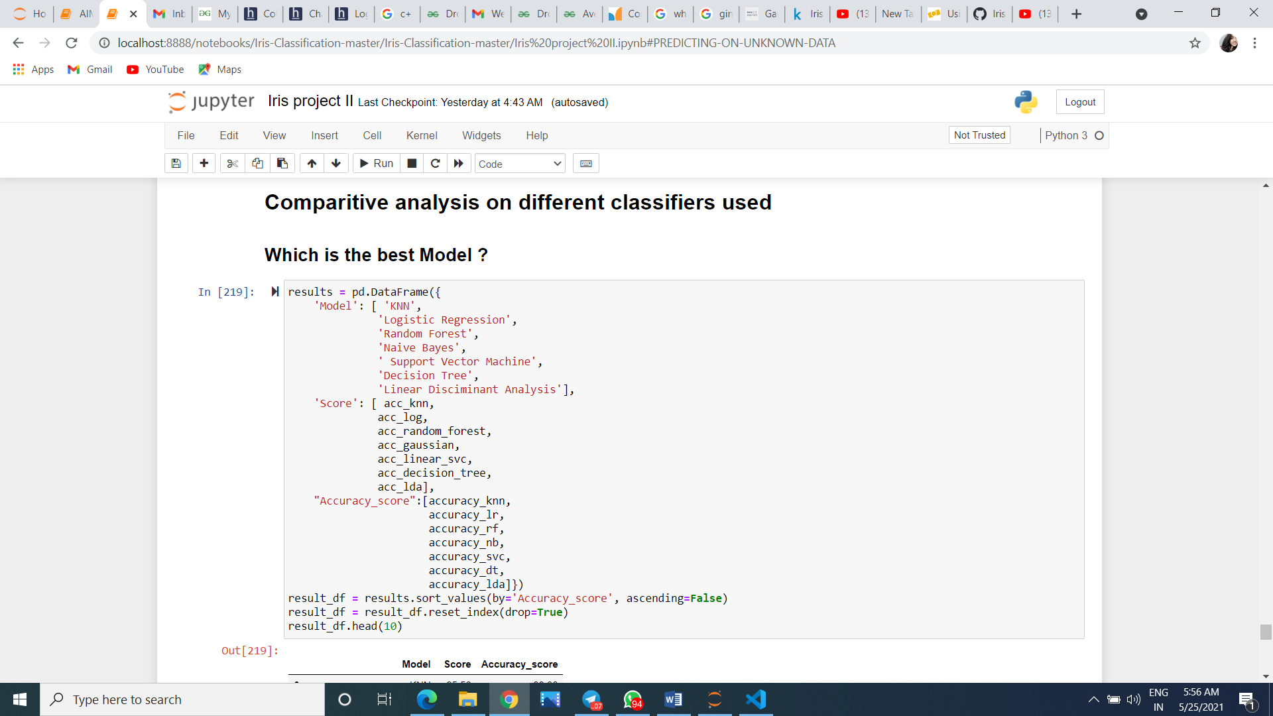

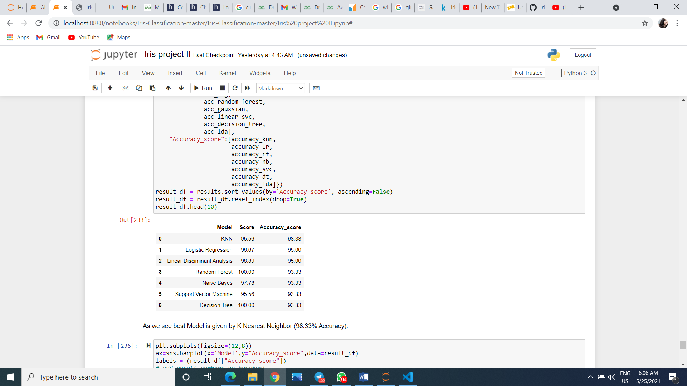

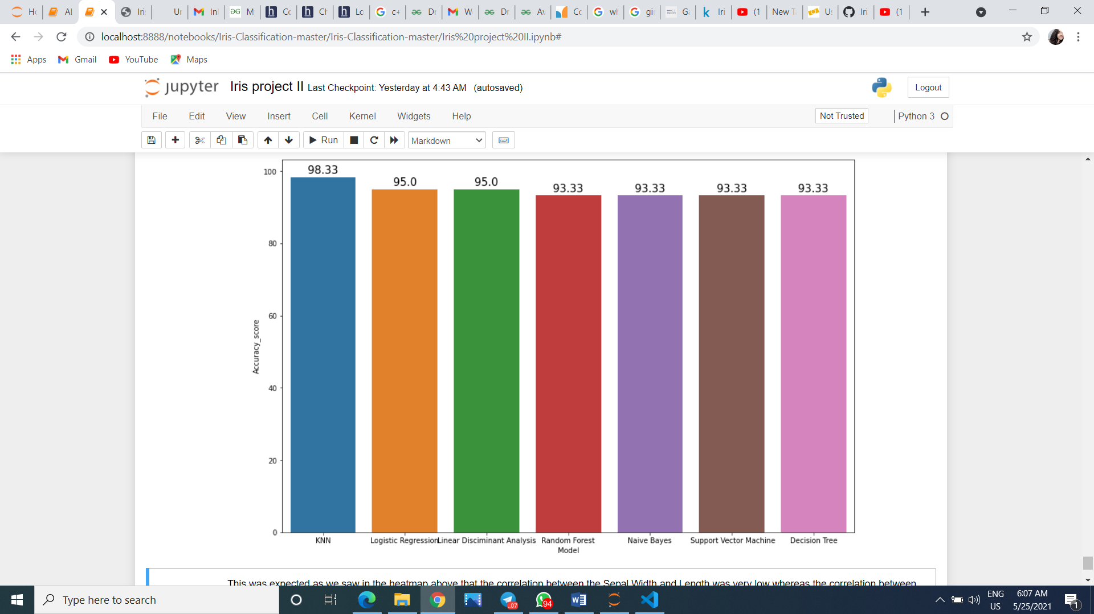

This was expected as we saw in the heatmap above that the correlation between the Sepal Width and Length was very low whereas the correlation between Petal Width and Length was very high. Thus we have just implemented some of the common Machine Learning Classifiers. Since the dataset is small with very few features. The accuracy differs with different datasets and

**CONCLUSION & FUTURE SCOPE**

As we know now **Machine Learning** is a hot topic nowadays, and has a lot of scope in near future,doing this project as a beginner made me learn many tools of ml and classification. I came to know a lot about supervised learning and its applications.

It is observed that among the seven classifiers KNN has the highest accuracy score although it varies among different data inputs given. This kind of classification is essential in many real life monitering systems like marking emails as spams and more. This classification works only when it is fed with some data and output as a training set(supervised learning). If atleast some labels are not given then it’s out of this scope and falls in unsupervised or reinforcement learning.

The Machine learning is the subfield of computer science, “computers are having the ability to learn without being explicitly programmed”. Evolved from the study of pattern recognition and computational learning theory in artificial intelligence machine learning explores the study and construction of algorithms that can learn from and make predictions on data such algorithms overcome following strictly static program instructions by making data-driven predictions or decisions, through building a model from sample inputs.

Same happened in this classification model where the machine itself studies the given dataset and identifies trends itself. When an unkown data is given it automatically identifies its label and gives the output.

Machine learning is changing the world by transforming all segments including healthcare services, education, transport, food, entertainment, and different assembly line and many more. It will impact lives in almost every aspect, including housing, cars, shopping, food ordering, etc. Technologies like Internet of Things (IoT) and cloud computing are all growing implementation of ML to enhance objects and gadgets into “smart” for themselves. ML offers potential value to companies trying to leverage big data for customer satisfaction. The hidden pattern buried in the data can be very useful for business.

**The downside**

With every discovery and step forward comes a range of both technological and moral implications of those innovations. Although ML helps humanity, this innovation can impact our normal lives when it begins to make a decision that has a personal impact on us. ML can take up most of our jobs and there can be an increased data privacy issue. We as a modern society will operate and function similar to open source.

**BIBLIOGRAPHY**

This project is made by taking help of several websites .The links are given below:

Wikipedia: <https://en.wikipedia.org/wiki/Iris_flower_data_set>

Scikit learn: <https://scikit-learn.org/stable/tutorial/basic/tutorial.html#introduction>

Neural designer: <https://www.neuraldesigner.com/learning/examples/iris-flowers-classification>

Kaggle: <https://www.kaggle.com/aceccon/2-iris-dataset-basic-classification-algorithms>

medium.com: <https://medium.com/@jebaseelanravi96/machine-learning-iris-classification-33aa18a4a983>